Social Commerce as a Catalyst for Agribusiness Development: Evaluating the Impact of TikTok Shop Training on Entrepreneurial Performance in Malaysia
Abd Razzif Abd Razak*, Siti Faizah Zainal, Siti Nurulaini Azmi, Nur Hafizah Roslan, Nur Syairah Ani
Faculty of Management and Economics, Universiti Pendidikan Sultan Idris, Perak, Malaysia
*Correspondence: razzif@fpe.upsi.edu.my
ABSTRACT  The proliferation of social commerce platforms has created new opportunities for agribusiness entrepreneurs to access markets beyond traditional distribution channels. This study evaluates the effectiveness of the Agromarketing Masterclass TikTok Shop Edition, a government-led digital entrepreneurship intervention implemented by the Federal Agricultural Marketing Authority (FAMA) in Malaysia. Employing a quantitative descriptive and correlational research design, the study analyses official programme performance data spanning June to December 2024, encompassing 80 participating companies, 160 entrepreneurs and 425 stock-keeping units. The findings demonstrate that the programme generated RM6,205,957.06 in cumulative sales, achieving a return on investment of approximately 1:31. Livestream sales constituted the largest channel contribution at 33.9 per cent of total revenue, followed by profile-window sales at 30.1 per cent and short-video sales at 26.1 per cent. Pearson correlation analysis using monthly aggregate data revealed that livestream sales (r = .989, p < .0001), short-video sales (r = .997, p < .0001), orders (r = .977, p = .0002) and products sold (r = .930, p = .0024) were strongly and significantly associated with total monthly sales. These findings support the Resource-Based View and Dynamic Capabilities perspectives, indicating that digital engagement, adaptive content capability and platform-based selling mechanisms function as strategic resources for agribusiness performance. The study contributes empirical evidence from an outcome-based public-sector digitalisation programme and provides actionable recommendations for policymakers and practitioners seeking to leverage social commerce for agribusiness development.  KEYWORDS: Social Commerce; Agribusiness Marketing; TikTok Shop; Digital Entrepreneurship; FAMA; Agropreneurship; Malaysia | MANUSCRIPT TYPE  Case Study  PUBLICATION DETAILS  Received: 10 January 2026  Revised: 15 March, 20 May 2026  Accepted: 10 June 2026

1. INTRODUCTION
The digital transformation of agricultural marketing has fundamentally altered how agribusiness entrepreneurs connect with consumers. Social commerce platforms, which integrate entertainment, social interaction and commercial transactions within a single digital ecosystem, have emerged as powerful mechanisms for market access. Unlike conventional e-commerce, social commerce leverages content-driven engagement, real-time interaction and algorithmic visibility to facilitate product discovery and purchase decisions. For agribusiness enterprises operating with limited marketing budgets and constrained distribution networks, these platforms offer a pathway to bypass traditional intermediaries and reach consumers directly.
In Malaysia, the Federal Agricultural Marketing Authority (FAMA) has been at the forefront of integrating digital marketing strategies into its agropreneurship development programmes. Recognising the transformative potential of platform-based commerce, FAMA launched the Agromarketing Masterclass TikTok Shop Edition, a structured intervention designed to equip agri-entrepreneurs with practical competencies in digital marketing, livestream selling and content creation. The programme represents a significant departure from conventional agricultural extension approaches, which have traditionally focused on production-oriented training rather than market-oriented digital capability building. By partnering with TikTok Shop, FAMA positioned participating entrepreneurs within an established social commerce ecosystem with access to millions of active users.
Despite the growing adoption of social commerce platforms in developing economies, empirical evidence on the economic outcomes of government-led digital entrepreneurship programmes remains limited. Existing studies have predominantly examined digital adoption intentions, perceived usefulness and technology acceptance among small and medium enterprises. While these contributions are valuable for understanding behavioural antecedents, they do not adequately address whether structured digital training interventions translate into measurable sales growth, income enhancement and return on investment. This gap is particularly pronounced in the agribusiness sector, where entrepreneurs face unique challenges including perishable inventory, seasonal demand fluctuations and geographically dispersed consumer bases.
The present study addresses this gap by evaluating the Agromarketing Masterclass TikTok Shop Edition using official programme performance data collected from June to December 2024. The study adopts a quantitative descriptive and aggregate correlational design to examine the relationship between digital engagement indicators and sales performance. Drawing on the Resource-Based View and Dynamic Capabilities Theory, the study positions digital skills, content creation capability and platform-based selling mechanisms as strategic resources that drive agribusiness performance in the social commerce environment.

2. LITERATURE REVIEW
2.1 Social Commerce and Agribusiness Marketing
Social commerce represents a paradigm shift in how agricultural products are marketed and distributed in the digital age. Unlike traditional e-commerce platforms that prioritise product catalogues and search-based discovery, social commerce platforms such as TikTok Shop embed purchasing decisions within an entertainment-oriented content ecosystem. Hajli (2015) conceptualised social commerce as a subset of e-commerce that involves social media technologies supporting social interactions and user contributions in commercial contexts. This framework is particularly relevant for agribusiness marketing, where product storytelling, authenticity and trust play critical roles in consumer decision-making.
Safari and Nik Mohd Masdek (2015), writing in the Journal of Agribusiness Marketing, demonstrated that Malaysian consumers are increasingly receptive to purchasing fresh agricultural products through electronic channels when logistics reliability and product quality assurances are present. Their findings underscore that seller-side digital capability must be matched by consumer-side acceptance if platform-based agribusiness marketing is to achieve scale.
The Agromarketing Masterclass TikTok Shop Edition represents a practical application of these theoretical insights within the Malaysian agricultural context. By training entrepreneurs to create short-video content, conduct livestream selling sessions and optimise their TikTok Shop profiles, the programme sought to translate digital capability into market performance. Abdul Rahman, Tan and Md Isa (2024) found that perceived relative advantage, organisational support and customer pressure significantly influence e-commerce adoption readiness among FAMA-registered fresh agricultural traders.
2.2 Resource-Based View and Digital Capabilities
The Resource-Based View provides a theoretical foundation for understanding how digital resources contribute to competitive advantage in agribusiness. Barney (1991) posited that resources must be valuable, rare, imperfectly imitable and non-substitutable to generate sustained competitive advantage. In the context of social commerce, digital marketing skills, content creation capability and platform-specific expertise function as strategic resources.

2.2 Resource-Based View and Digital Capabilities
Kraus et al. (2022) extended the RBV framework to digital entrepreneurship, arguing that digital technologies enable new business models by reducing transaction costs and expanding market reach. Nambisan (2017) further emphasised that digital entrepreneurship is characterised by the convergence of digital tools, digital platforms and digital artefacts. These theoretical developments are directly applicable to the present study, as the programme provided entrepreneurs with platform access, training in digital tools and the ability to create digital artefacts in the form of short videos and livestream content.
2.3 Dynamic Capabilities in Platform-Based Commerce
Dynamic Capabilities Theory complements RBV by explaining how entrepreneurs adapt, reconfigure and renew their resources in response to changing market conditions. In the platform economy, capability is not static; sellers must continuously learn from content performance, adjust livestream timing, test product bundles and refine customer communication strategies. The six-month monitoring component of the Agromarketing Masterclass TikTok Shop Edition created conditions for capability development by providing entrepreneurs with ongoing performance feedback and opportunities to iteratively improve their selling practices.
Shamsudin et al. (2025), in the Journal of Agribusiness Marketing, examined how FAMA direct sales programmes can improve market access and economic resilience among small agricultural producers. Although their study focused on conceptual pathways rather than social commerce outcomes, it reinforces the institutional logic underpinning FAMA-led interventions: public marketing agencies can reduce intermediary dependence when producers are equipped with market-facing capabilities.
2.4 Hypotheses Development
Drawing on the theoretical framework outlined above, this study proposes that digital skills, entrepreneurial mindset and content innovation collectively strengthen engagement intensity on TikTok Shop. Engagement intensity, reflected in livestream activity, short-video visibility and product movement, is expected to translate into income growth and economic returns. The conceptual model also positions FAMA support and digital infrastructure as contextual factors that may moderate the relationship between engagement and economic outcomes.
H1: Digital skills are positively associated with engagement intensity on TikTok Shop. H2: Entrepreneurial mindset is positively associated with engagement intensity on TikTok Shop. H3: Content innovation is positively associated with engagement intensity on TikTok Shop. H4: Engagement intensity is positively associated with income growth among participating entrepreneurs. H5: Engagement intensity is positively associated with return on investment. H6: FAMA support and digital infrastructure moderate the relationship between engagement intensity and income growth.

3. METHODOLOGY
3.1 Research Design
This study employed a quantitative descriptive and aggregate correlational research design. The descriptive component documented the distribution of participating companies, sales channel performance and programme outcomes. The correlational component examined the strength and direction of associations between digital engagement indicators and monthly sales performance. The design was selected because the available dataset comprised programme-generated numerical indicators rather than primary survey responses, making correlational analysis the most appropriate approach for identifying meaningful patterns within the data.
3.2 Data Source and Coverage
The dataset for this study was the Projek Perintis Report (December 2024), provided by the Federal Agricultural Marketing Authority. The report consisted of two components: the Summary sheet, which reported sales by platform channel, seller content distribution, assortment performance and order distribution; and the Seller Gross Merchandise Value sheet, which recorded seller-level performance for 80 participating companies. The analysis covered the programme implementation period from June to December 2024. May 2024 data, representing a pre-programme baseline month, were excluded from the main correlation analysis to maintain consistency with the stated programme period.
3.3 Variables and Analytical Strategy
The dependent variable for the aggregate correlation analysis was total monthly sales in Malaysian Ringgit. The independent indicators included livestream sales, short-video sales, profile-window sales, other shop-tab sales, live-stream content volume, short-video content volume, total content volume, products sold, products available for sale and total orders. Pearson correlation analysis was used to examine the direction and strength of the relationship between each indicator and total monthly sales. Given that the dataset contained seven programme months, the correlation analysis was interpreted as aggregate programme-level evidence rather than individual-level causal inference.
3.4 Data Collection Process
Data were compiled through an eight-stage administrative process: recruitment and registration, training delivery, TikTok Shop activation, monthly monitoring, extraction of sales records, data cleaning, descriptive and Pearson correlation analysis, and interpretation against theoretical, policy and industry implications. This sequential process ensured that reported outcomes were traceable to official programme documentation.

4. FINDINGS
4.1 Descriptive Analysis of Programme Participation
The Agromarketing Masterclass TikTok Shop Edition attracted participation from 80 companies across 14 Malaysian states and federal territories. Selangor recorded the highest number of participants with 33 companies, followed by Perak and Kelantan with 8 companies each. This distribution reflects the concentration of digital economic activity in the Klang Valley region, which benefits from more developed digital infrastructure, higher internet penetration and greater access to logistics networks. The participation of entrepreneurs from less developed states, including Sabah and Sarawak, demonstrates the programme's reach beyond the Peninsular Malaysian economic core, although the lower representation suggests that additional targeted interventions may be necessary.
Table 1: Distribution of Participating Companies by State (Agromarketing Masterclass TikTok Shop Edition)
No. | State | Number of Companies (n) | Share of Total (%)
1 | Perlis | 1 | 1.3
2 | Kedah | 3 | 3.8
3 | Penang | 2 | 2.5
4 | Perak | 8 | 10.0
5 | Kuala Lumpur | 6 | 7.5
6 | Selangor | 33 | 41.3
7 | Negeri Sembilan | 5 | 6.3
8 | Melaka | 1 | 1.3
9 | Johor | 4 | 5.0
10 | Pahang | 3 | 3.8
11 | Kelantan | 8 | 10.0
12 | Terengganu | 4 | 5.0
13 | Sabah | 1 | 1.3
14 | Sarawak | 1 | 1.3
Total |  | 80 | 100.0
Source: FAMA TikTok Shop Performance Report (2024).

4.2 Programme Performance Summary
The programme involved 80 companies and 160 participants across two training cohorts. A total of 425 stock-keeping units were marketed, spanning both fresh and processed product categories. Notably, 69 companies focused on processed products while 11 companies marketed fresh products. The programme also demonstrated inclusive impact, with 13 companies owned by persons with disabilities achieving meaningful sales outcomes.
In terms of direct sales performance, the programme generated RM12,657.15 during a two-hour live session in June 2024 and RM4,274.31 in a subsequent July 2024 session. Total sales in December 2024 reached RM1,705,942.05, contributing to cumulative sales of RM6,205,957.06 over the full programme period. The return on investment ratio of 1:31 indicates that for every RM1.00 invested in the programme, participants generated RM31.00 in economic returns.
Table 2: Summary of Agromarketing Masterclass TikTok Shop Edition (AMTTSE) Performance Report
No. | Item | Description / Value
1 | Number of Companies | 80
2 | Number of Participants | 160
3 | Number of Training Courses Conducted | 2
4 | Companies in Fresh Product Category | 11
5 | Companies in Processed Product Category | 69
6 | Total Stock Keeping Units (SKUs) Marketed | 425
7 | Companies Owned by Persons with Disabilities (PWD) | 13
8 | Sales during 2-hour Live Session (June 2024) | RM12,657.15
9 | Sales during 2-hour Live Session (July 2024) | RM4,274.31
10 | Total Sales in December 2024 | RM1,705,942.05
11 | Total Cumulative Sales (June - December 2024) | RM6,205,957.06
12 | Return on Investment (ROI) | 1:31 - For every RM1.00 invested, participants gained RM31.00 in economic returns.
Source: FAMA TikTok Shop Performance Report (2024).
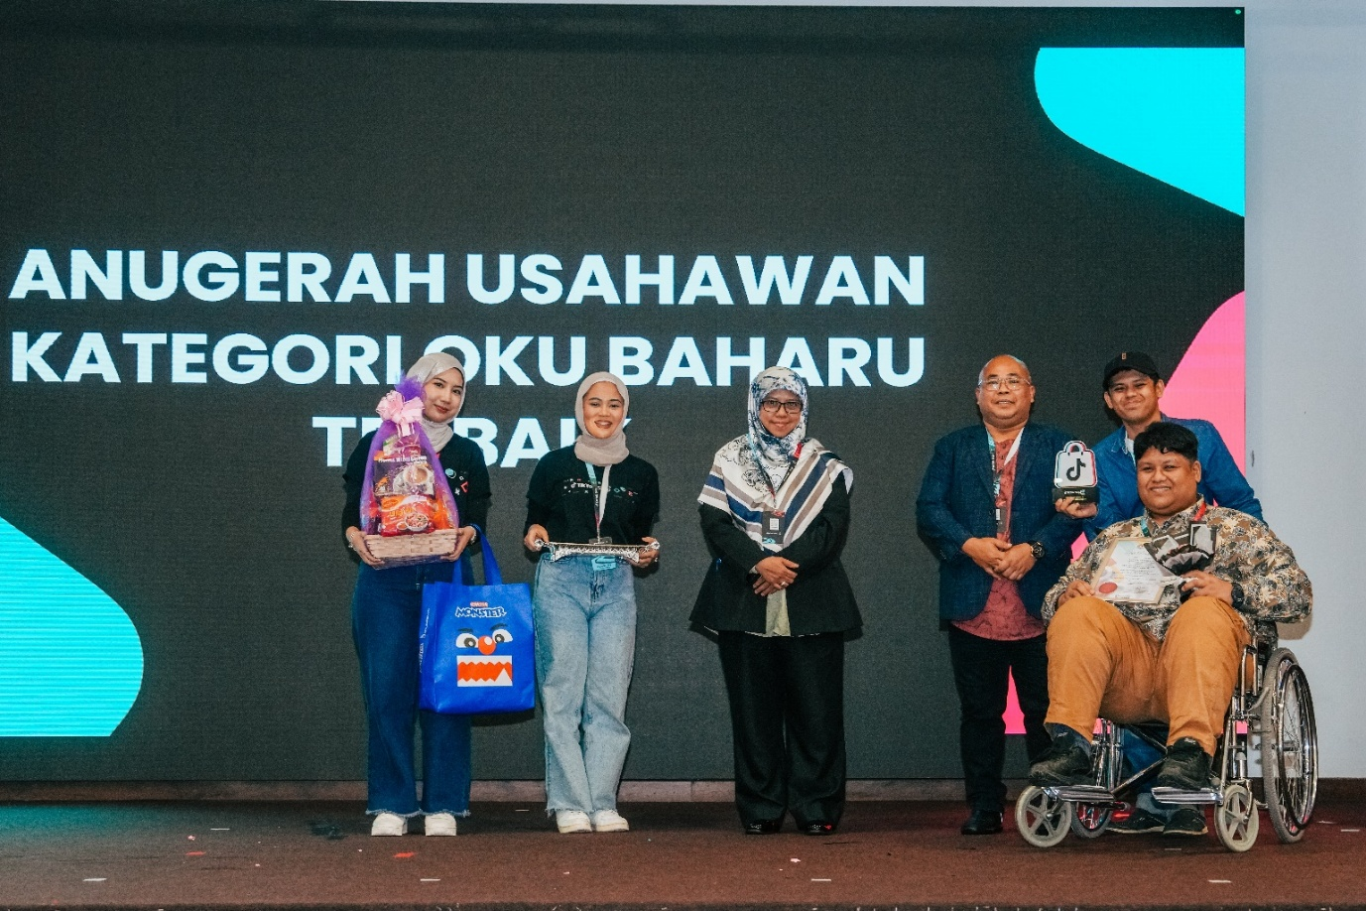
Figure 1: Nurezqi Enterprise, which began as a home-based business and operated at FAMA Farmers' Markets in Ipoh, Perak, has successfully expanded nationwide, including to Sabah and Sarawak, through online sales on the TikTok Shop platform. This achievement, catalysed by the Agromarketing Masterclass TikTok Shop Edition organised by FAMA, demonstrates the transformative impact of digital marketing adoption among entrepreneurs with disabilities. The company was awarded the Best New OKU Entrepreneur Award during the programme's live-streaming competition.

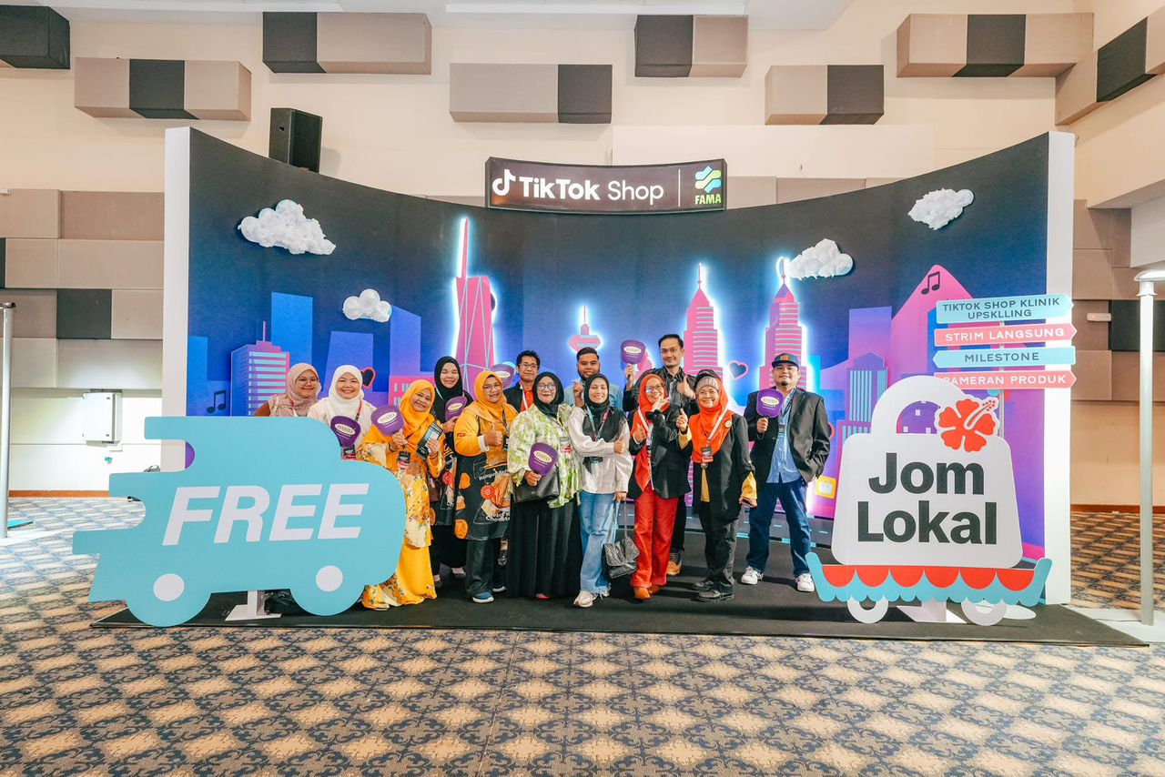
Figure 2: A group of FAMA entrepreneurs posing at the TikTok Shop x FAMA exhibition backdrop during the Agromarketing Masterclass TikTok Shop Edition event. The Jom Lokal campaign highlighted the importance of promoting locally produced agro-based products through digital commerce and live-streaming marketing on the TikTok Shop platform.
4.3 Sales Performance by Channel
Livestream selling emerged as the highest-performing channel, generating RM2,105,670.00 and accounting for 33.9 per cent of total sales. Profile-window sales contributed RM1,875,034.00, short-video sales generated RM1,621,255.00, while other channels contributed RM603,998.06. These findings demonstrate that live interactive commerce and persistent storefront presence were the dominant drivers of sales within the programme.
Table 3: Sales Value by Sales Channel in Agromarketing Masterclass TikTok Shop Edition (AMTTSE)
Sales Channel | Description | Sales Value (RM) | Share of Total (%)
Livestream | Sales generated through live-stream sessions conducted by FAMA entrepreneurs on TikTok Shop | 2,105,670.00 | 33.9
Short Video | Sales from short-video content that drives product visibility and conversions | 1,621,255.00 | 26.1
Window (Profile Sales) | Purchases made directly through the entrepreneur's TikTok Shop profile window | 1,875,034.00 | 30.1
Others (Shop Tab) | Sales recorded through the general Shop Tab browsing feature on TikTok Shop | 603,998.06 | 9.9
Total |  | 6,205,957.06 | 100.0
Source: FAMA TikTok Shop Performance Report (2024).

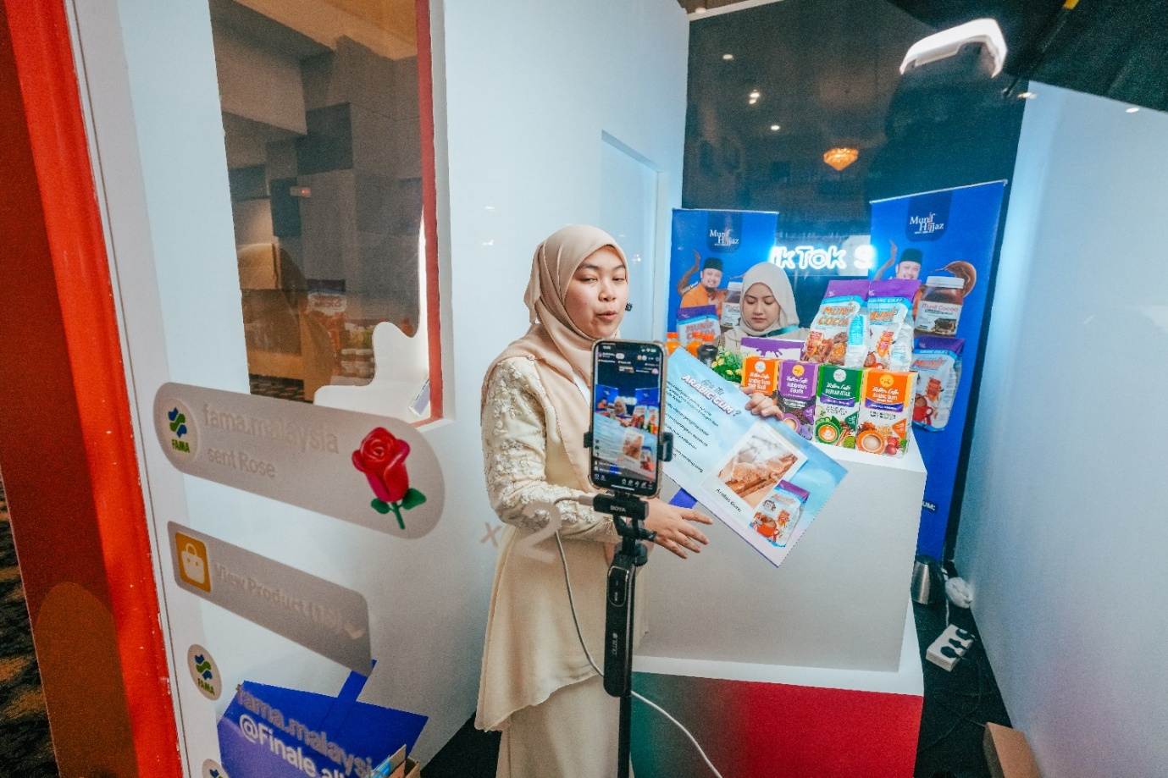
Figure 3: Munif Cocoa achieved the second-highest total sales value of RM736,162.87, following Azhar Food. The company's unexpected success was particularly remarkable as it marked their first experience with live-streaming sales. Participation in the Agromarketing Masterclass TikTok Shop Edition Live Streaming Competition encouraged the company to explore new online markets, significantly enhancing their digital business performance and market reach.
4.4 Monthly Performance Trends
Monthly programme performance from June to December 2024 reveals a clear upward trajectory in sales performance, with total monthly sales increasing from RM497,762.95 in June to RM1,705,942.05 in December. Livestream and short-video sales both exhibited steady growth over the period, with short-video sales accelerating notably in November and December. Products sold increased from 21,280 units in June to 45,192 units in December, while orders grew from 3,271 to 14,571 over the same period.
The progressive improvement in sales performance suggests that entrepreneurs became more proficient in using the TikTok Shop platform over time, consistent with the Dynamic Capabilities perspective. The steep acceleration in November and December may also reflect seasonal demand patterns associated with the year-end holiday period, as well as the cumulative effect of sustained content creation and audience building.

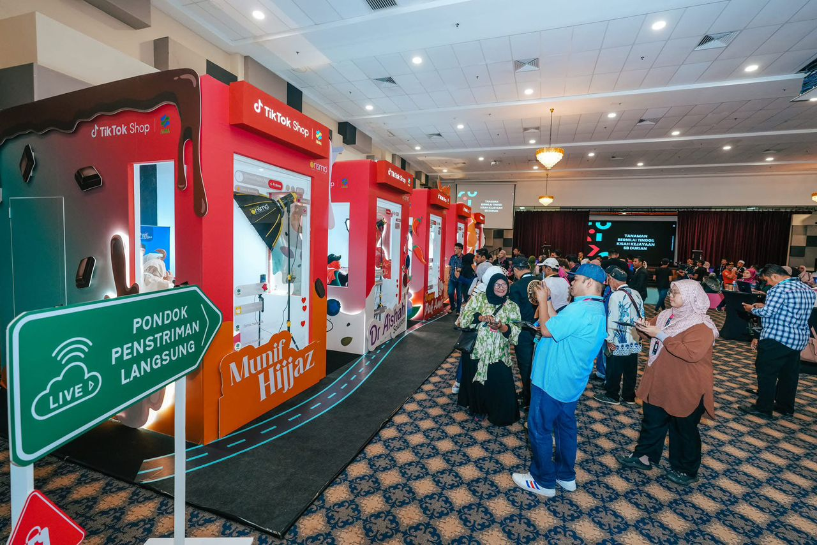
Figure 4: Visitors observing live-streaming sessions conducted by participating entrepreneurs in dedicated booths during the Agromarketing Masterclass TikTok Shop Edition Grand Final. The live-streaming pods, branded with participating companies such as Munif Hijjaz, served as experiential learning spaces where FAMA entrepreneurs demonstrated real-time digital marketing and e-commerce engagement strategies.
Table 4: Monthly Programme Performance, June to December 2024
Month | Total Sales (RM) | Livestream (RM) | Short Video (RM) | Products Sold | Orders
June | 497,762.95 | 194,759.55 | 180,940.23 | 21,280 | 3,271
July | 507,967.92 | 174,190.65 | 193,101.29 | 22,298 | 3,381
August | 728,225.46 | 259,453.12 | 300,783.08 | 34,583 | 4,645
September | 692,259.02 | 263,009.12 | 263,940.70 | 25,617 | 7,159
October | 814,482.14 | 323,530.03 | 317,551.16 | 32,334 | 6,164
November | 1,259,317.52 | 402,162.25 | 638,313.61 | 37,804 | 10,194
December | 1,705,942.05 | 582,847.27 | 871,599.37 | 45,192 | 14,571
Source: Projek Perintis Report (December 2024), Summary sheet.

4.5 Seller-Level GMV Distribution
The Seller GMV sheet recorded 80 participating companies, with December seller-level GMV totalling RM1,705,942.05. The distribution was highly skewed: 55 sellers recorded positive GMV while 25 sellers recorded zero GMV during the December reporting period. The top ten sellers accounted for a disproportionately large share of total GMV, indicating that programme success was concentrated among entrepreneurs who were able to activate stronger content, sales execution and customer conversion capabilities.
Table 5: Top Ten Sellers by Gross Merchandise Value (GMV) in December 2024
Rank | Shop Name | Batch | SOF | OKU | GMV (RM)
1 | Chef Ustazah HQ | Batch 2 | N | No | 689,517.94
2 | kerepek azharfood | Batch 1 | N | No | 533,945.85
3 | Munif Cocoa @ Koko Spread Sedap | Batch 1 | N | No | 173,804.07
4 | DASTO HQ | Batch 2 | N | No | 107,254.26
5 | Dapur Pak Amir | Batch 1 | N | Yes | 39,562.30
6 | Baja Taiping | Batch 2 | N | No | 37,368.97
7 | Ayamhalalbismi | Batch 1 | Y | No | 20,120.58
8 | RIZQ MART | Batch 1 | Y | Yes | 15,701.73
9 | Corndog Anak Ramai HQ | Batch 2 | Y | No | 10,396.60
10 | agromasmalaysia | Batch 1 | N | No | 9,817.92
Source: Projek Perintis Report (December 2024), Seller GMV sheet. SOF = Sales from Farm. OKU = Orang Kurang Upaya (Persons with Disabilities).
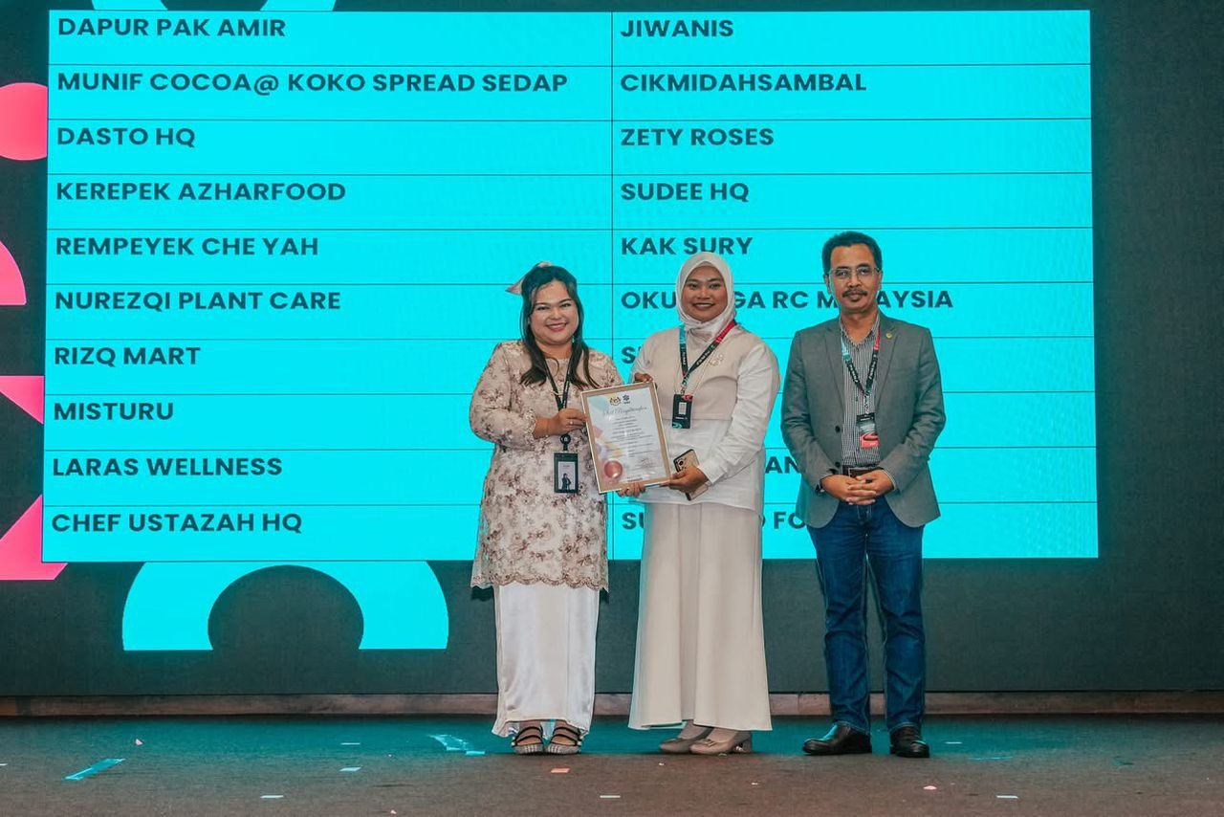
Figure 5: A representative from Misturu, one of the Top 20 finalists from Johor, receiving a certificate of recognition during the Agromarketing Masterclass TikTok Shop Edition Grand Final. The company's participation reflects the growing engagement of southern region entrepreneurs in adopting digital marketing strategies through the TikTok Shop platform, contributing to nationwide agri-entrepreneurial transformation.

4.6 Pearson Correlation Analysis
Pearson correlation analysis was conducted using monthly aggregate programme data for June to December 2024. The results should be interpreted as programme-level associations rather than seller-level behavioural correlations, as seller-level livestream frequency, views and engagement rates were not available in the dataset. The strongest positive association was observed between short-video sales and total monthly sales, followed by livestream sales, orders, other shop-tab sales, profile-window sales and products sold.
Notably, content volume indicators were not consistently significant. Live-stream content volume showed a positive but marginal relationship, while short-video content volume and total content volume were not statistically significant. This finding suggests that content quality, relevance and conversion capability may be more important determinants of sales performance than content quantity alone. Products available for sale also did not correlate significantly with total sales.
Table 6: Pearson Correlation Analysis Using Monthly Aggregate Programme Data (n = 7)
Indicator correlated with total monthly sales | Pearson r | p-value | Significance
Livestream sales (RM) | 0.989 | <.0001 | **
Short-video sales (RM) | 0.997 | <.0001 | **
Profile/window sales (RM) | 0.971 | 0.0003 | **
Other/shop-tab sales (RM) | 0.972 | 0.0002 | **
Live-stream content volume | 0.720 | 0.0683 | ns
Short-video content volume | 0.414 | 0.3556 | ns
Total content volume | 0.538 | 0.2133 | ns
Products sold | 0.930 | 0.0024 | **
Products for sale | -0.011 | 0.9807 | ns
Orders | 0.977 | 0.0002 | **
Note: ** p < .01; ns = not significant. Source: Author's calculation based on Projek Perintis Report (December 2024).

5. DISCUSSION
The findings of this study demonstrate that the Agromarketing Masterclass TikTok Shop Edition generated measurable economic outcomes for participating agri-entrepreneurs and that these outcomes were most strongly associated with monetised social commerce activities, particularly short-video and livestream sales. The cumulative sales of RM6.2 million and ROI of 1:31 represent a substantial economic return on a relatively modest public-sector investment in digital capability building.
From a Resource-Based View perspective, the findings indicate that digital skills and content creation capability functioned as strategic resources for participating entrepreneurs. Those who were able to present their products persuasively through short videos, communicate authentically during livestream sessions and maintain well-organised storefronts possessed capabilities that differentiated them from less active competitors.
The Dynamic Capabilities perspective is supported by the progressive improvement in sales performance observed over the six-month monitoring period. Entrepreneurs who persisted in content creation, refined their selling approaches and responded to platform analytics demonstrated increasing sales trajectories. The correlation analysis introduces an important qualification to the narrative of programme success: content volume alone does not automatically translate into sales performance; quality, relevance and conversion effectiveness are more critical determinants.
The skewed distribution of seller-level GMV, with 25 of 80 sellers recording zero GMV in December and the top ten sellers accounting for a disproportionate share of total sales, indicates that programme benefits were not uniformly distributed. This pattern is common in platform-based commerce and suggests the need for targeted support for moderate and low-performing participants.

6. PRACTICAL IMPLICATIONS
For FAMA and other agricultural development agencies, the findings support the continuation and scaling of the Agromarketing Masterclass TikTok Shop Edition model, with several refinements. Training programmes should differentiate between participation, content production and conversion performance. Modules should focus not only on technical skills such as going live or uploading videos, but also on content conversion strategy, product bundling, offer structuring, customer response scripts, fulfilment reliability and post-campaign analytics.
For entrepreneurs, the findings indicate that sales growth depends on consistent execution rather than mere account registration or product listing. Active content creation, regular livestream scheduling and responsive customer engagement are essential practices for achieving meaningful revenue outcomes. Entrepreneurs should focus on content quality and conversion optimisation alongside content volume.
7. POLICY IMPLICATIONS
The programme provides evidence that public-sector digitalisation initiatives can produce direct economic returns when linked to platform partnership, performance monitoring and market-based outcome tracking. Policymakers should consider incorporating standardised digital performance metrics into agricultural development programme design, including sales volume, channel contribution, product movement and order conversion rates. A monthly seller analytics dashboard would enable real-time performance tracking and early identification of entrepreneurs requiring additional support.
Furthermore, the geographic concentration of participants in Selangor and other economically developed states suggests that future programme iterations should include targeted outreach strategies for less developed regions. This may include providing additional logistical support, subsidised internet access and location-specific mentoring.

8. CONCLUSION
This study evaluated the effectiveness of the Agromarketing Masterclass TikTok Shop Edition, a government-led digital agropreneurship intervention implemented by FAMA in Malaysia. The findings demonstrate that the programme generated RM6,205,957.06 in cumulative sales from June to December 2024, achieving a return on investment of approximately 1:31. Livestream selling was the highest-performing channel, followed by profile-window sales and short-video sales. Pearson correlation analysis revealed that total monthly sales were strongly and significantly associated with short-video sales, livestream sales, orders and products sold. However, content volume alone was not significantly correlated with sales, suggesting that content quality and conversion effectiveness are more important determinants of commercial success than content quantity.
The analysis also introduced a balanced interpretation of programme outcomes. The available dataset supports aggregate programme-level correlation but does not permit seller-level causal claims, as individual livestream frequency, video views, engagement rates and seller-level ROI were not available. Future programme monitoring should therefore collect standardised seller-level analytics, including live session frequency, live duration, viewer counts, short-video views, product click-through rates, conversion rates, order values, repeat purchase rates and seller-level ROI.
The study recommends that FAMA establish a comprehensive Post-Masterclass Digital Business Clinic, a monthly seller analytics dashboard and a tiered mentorship system that provides differentiated support for high-potential, moderate-performing and inactive participants. Overall, the programme demonstrates that social commerce can function as a credible economic instrument for agribusiness development when training, platform access, content capability building and performance monitoring are integrated within a coherent programme design.

DATA AVAILABILITY
The data supporting the findings of this study are available from the corresponding author upon reasonable request.
FUNDING INFORMATION
This research received no external funding.
ETHICS APPROVAL
Not applicable.
CONFLICT OF INTEREST
The authors declare no conflict of interest.
AUTHOR CONTRIBUTIONS
Abd Razzif bin Abd Razak contributed to conceptualization, resources, data curation, writing original draft preparation, visualization, supervision, and project administration. Siti Faizah binti Zainal contributed to conceptualization, validation, data curation, visualization, and project administration. Siti Nurulaini binti Azmi contributed to methodology, validation, resources, writing original draft preparation, and supervision. Nur Hafizah binti Roslan contributed to methodology, software, formal analysis, investigation, and writing review and editing. Nur Syairah binti Ani contributed to software, formal analysis, investigation, and writing review and editing. All authors have read and approved the final version of the manuscript.
DISCLOSURE OF AI USE
AI tools were not used in the preparation of this manuscript.
ACKNOWLEDGEMENT
The authors express sincere appreciation to the Federal Agricultural Marketing Authority (FAMA), TikTok Shop Malaysia and all participating entrepreneurs involved in the Agromarketing Masterclass TikTok Shop Edition. Appreciation is also extended to the programme implementation and monitoring teams who contributed to the availability of performance data used in this study.

REFERENCES
Abdul Rahman, S. F., Tan, P.-L., & Md Isa, A. (2024). Technology adoption readiness among fresh agricultural traders in using e-commerce platform in Malaysia. Journal of Agribusiness Marketing, 13(2). https://doi.org/10.56527/jabm.13.2.5
Barney, J. (1991). Firm resources and sustained competitive advantage. Journal of Management, 17(1), 99-120. https://doi.org/10.1177/014920639101700108
Kaur, B., Kamarulzaman, N. H., & Hamzah, N. A. (2015). The impact of public-assisted contract farming programmes in Malaysia. Journal of Agribusiness Marketing, 7(1).
Creswell, J. W., & Creswell, J. D. (2018). Research design: Qualitative, quantitative, and mixed methods approaches (5th ed.). SAGE Publications.
FAMA. (2024). Projek Perintis Report (December 2024): Agromarketing Masterclass TikTok Shop Edition performance dataset. Federal Agricultural Marketing Authority.
Hajli, N. (2015). Social commerce constructs and consumer's intention to buy. International Journal of Information Management, 35(2), 183-191. https://doi.org/10.1016/j.ijinfomgt.2014.12.005
Halim, I. A., Gian Singh, J. K., & Osman, R. (2026). Bridging the digital gap: Factors influencing digital economy adoption in small enterprises. Journal of International Business, Economics and Entrepreneurship, 11(1), 32-42. https://doi.org/10.24191/jibe.v11i1.8520
Kraus, S., Palmer, C., Kailer, N., Kallinger, F. L., & Spitzer, J. (2022). Digital entrepreneurship: A research agenda on new business models for the twenty-first century. International Journal of Entrepreneurial Behavior & Research, 28(5), 1172-1193.
Nambisan, S. (2017). Digital entrepreneurship: Toward a digital technology perspective of entrepreneurship. Entrepreneurship Theory and Practice, 41(6), 1029-1055. https://doi.org/10.1111/etap.12254
Putit, L., Hamzah, M. I., Abdullah, M. F., Syed Annuar, S. N., & Yulianto, A. (2025). Drivers of social media marketing continuance among MSMEs in emerging economies. Journal of International Business, Economics and Entrepreneurship, 10(2), 86-97. https://doi.org/10.24191/jibe.v10i2.8743
Rauch, A., & Frese, M. (2007). Let's put the person back into entrepreneurship research: A meta-analysis on the relationship between business owners' personality traits, business creation and success. European Journal of Work and Organizational Psychology, 16(4), 353-385. https://doi.org/10.1080/13594320701595438
Safari, S., & Nik Mohd Masdek, N. R. (2015). Consumers' perception and acceptance of fresh agriculture product purchased through e-business. Journal of Agribusiness Marketing, 7(1).
Shamsudin, M. F., Musa, W. A., Jalaludin, M. N. H., & Jamaludin, A. (2025). Assessing the impact of FAMA's direct sales programmes on small agricultural producers in Malaysia: A conceptual analysis. Journal of Agribusiness Marketing, 14(1). https://doi.org/10.56527/jabm.14.1.2
Teece, D. J. (2018). Business models and dynamic capabilities. Long Range Planning, 51(1), 40-49. https://doi.org/10.1016/j.lrp.2017.06.007
Yin, R. K. (2018). Case study research and applications: Design and methods (6th ed.). SAGE Publications.

