From Digital Access to Unequal Value Capture: Social Commerce and Agropreneur Performance Inequality in an Emerging Economy
Journal of Agribusiness in Developing and Emerging Economies (JADEE) — Research Paper (Revised Submission)
Abd Razzif Abd Razak*, Siti Faizah Zainal, Siti Nurulaini Azmi, Nur Hafizah Roslan, Nur Syairah Ani
Faculty of Management and Economics, Universiti Pendidikan Sultan Idris, Perak, Malaysia

Abstract
Purpose. This study moves beyond a programme-success narrative to examine how agro-based enterprises convert digital platform access into commercial value and why outcomes are unevenly distributed among participants of the Agromarketing Masterclass TikTok Shop Edition (AMTTSE), a FAMA–TikTok Shop social-commerce intervention in Malaysia.
Design/methodology/approach. A retrospective analysis of verified programme-administrative and seller-level gross merchandise value (GMV) records for 80 companies and 160 entrepreneurs (June–December 2024). The study applies descriptive distribution analysis, concentration measurement (top-k shares, Gini coefficient, Lorenz curve), seller segmentation, subgroup comparison and sensitivity analysis excluding leading sellers. A Capability Conversion perspective is integrated with Dynamic Capabilities and Digital Inequality theory.
Findings. Cumulative sales reached RM6,205,957.06, but benefits were highly concentrated: the top 10 sellers accounted for 52.4 per cent of December GMV and the seller-level Gini coefficient was approximately 0.71. Of 80 companies, 25 recorded zero GMV while 55 were active. Short-video (44.6 per cent) and livestream (35.4 per cent) channels dominated value capture. Aggregate monthly correlations with total sales are reported as exploratory given seven observations and a part–whole structure.
Originality/value. The article is materially distinct from the prior JIBE publication: it addresses a new research problem (performance inequality rather than programme effectiveness), uses a differentiated unit of analysis (seller-level concentration), adds genuine analytical value (Gini, Lorenz, segmentation, sensitivity) and contributes a Capability Conversion framework for inclusive digital agribusiness policy. Prior publication is disclosed transparently to the editor.
Keywords: Digital agribusiness; agropreneurship; social commerce; market access; emerging economy; digital inclusion; performance concentration; agrifood MSMEs; Malaysia
Article classification: Research Paper

Plain Language Summary
A Malaysian government agency (FAMA) partnered with TikTok Shop to teach agro-based small businesses how to sell online through the Agromarketing Masterclass TikTok Shop Edition. Across seven months, 80 companies and 160 entrepreneurs generated RM6.2 million in sales. This article asks a different question from the usual ‘did the programme work?’ evaluation: it asks who captured that value. Using the programme’s own sales records, we show that the top 10 sellers earned over half of December sales, the typical seller earned only RM1,284, and 25 companies sold nothing at all. The lesson for emerging economies is that training plus platform access is not the same as inclusion: agencies must measure how value is distributed, not merely how much value is created, and must design support for the sellers who were left behind.

1. Introduction
Public agencies across emerging economies are investing heavily in social-commerce training as a mechanism for agribusiness development, attracted by the promise that platform-mediated retailing can lower the geographic, intermediary and information barriers that have historically constrained rural and small-scale agricultural enterprises (Deichmann et al., 2016; Aker, 2011). In Malaysia, the Federal Agricultural Marketing Authority (FAMA) introduced the Agromarketing Masterclass TikTok Shop Edition (AMTTSE) — retained throughout this manuscript exactly as the official programme brand — to strengthen the practical selling capability of agro-based micro and small enterprises on the TikTok Shop platform. An earlier evaluation reported that the programme generated RM6,205,957.06 in cumulative sales across 80 companies and 160 entrepreneurs between June and December 2024, with a reported return on investment of 1:31, a result that positioned the intervention as a credible model for public–platform collaboration in agricultural marketing (Abd Razzif et al., 2026).
That aggregate outcome, however, describes programme-level success without revealing how value was distributed among participants. Equal access to training and a digital platform does not automatically produce equal commercial returns, because enterprises differ in the resources, routines and adaptive capacities required to convert attention into transactions (Teece, 2018; Eisenhardt and Martin, 2000). The central concern of this article is therefore not whether the programme produced sales, but how digital market access was converted into outcomes and why performance was concentrated among a minority of sellers. This reframing matters for policy: a headline GMV figure can conceal a long tail of inactive or low-performing participants whose inclusion is the explicit rationale for public expenditure (Heeks, 2022).
The distinction between access and conversion is not merely semantic. When a government agency reports that a programme trained 160 entrepreneurs and generated RM6.2 million, the implicit claim is that training caused broadly distributed commercial benefit. The seller-level evidence tells a more nuanced story: a majority of participants sold little or nothing, while a small group captured most of the value (FAMA, 2024). Treating these two facts as equivalent would lead policymakers to scale a model whose inclusiveness is unproven. This article therefore interrogates the distribution behind the aggregate, asking whether digital agribusiness intervention in an emerging economy produces inclusion or merely amplifies pre-existing capability differences (van Deursen and van Dijk, 2019; Scheerder et al., 2017).
Why unequal value capture matters. The distribution of commercial outcomes within a public programme is not an implementation detail; it is the crux of the development claim. If the rationale for public spending is to extend market access to small agro-enterprises that would otherwise be excluded, then a programme whose benefits accrue overwhelmingly to a convertible elite has failed its own objective even if its aggregate statistics are impressive. Unequal value capture is consequential because it determines who can reinvest in production capacity, who remains dependent on intermediaries, and whether digital market access narrows or widens the rural–urban enterprise divide (Lepak et al., 2007; Gans and Ryall, 2017). Development agencies cannot manage what they do not measure; a concentration-adjusted reading of programme data is therefore a precondition for inclusive agribusiness policy rather than an optional scholarly refinement.
Why emerging economies matter. The Malaysian setting is instructive because it combines high mobile-internet penetration with persistent rural–urban enterprise disparities, a configuration shared across much of Southeast and South Asia. FAMA’s mandate to improve market access for small agricultural producers makes it a natural convenor of a platform partnership, but the same structural inequalities that limit rural enterprises offline do not disappear when those enterprises move online (van Dijk, 2020; Heeks, 2022). If anything, platform algorithms that reward engagement may intensify inequality by funnelling visibility to sellers who already convert well (Cutolo and Kenney, 2021). Evidence from China and Vietnam shows that digital channels can raise smallholder incomes, but the gains are conditional on skills, logistics and institutional support rather than guaranteed by access alone (Li et al., 2021; Liu et al., 2024; Hoang and Tran, 2023). The AMTTSE data offer a rare opportunity to observe this dynamic with verified transaction records rather than self-reported perceptions.
Why agribusiness differs from general e-commerce. Agrifood sales impose conversion constraints that generic e-commerce models do not capture. Perishability compresses the fulfilment window, food-safety requirements condition trust, product standardisation is harder for small producers, and seasonality concentrates both supply and demand (Barrett, 2008; Reardon and Timmer, 2014). An agro-enterprise that performs brilliantly in content creation can still fail commercially if it cannot meet fulfilment discipline, maintain cold-chain integrity or reassure consumers about quality (Morepje et al., 2024). Agribusiness therefore cannot be treated as a vertical application of general platform-retailing theory; the specific material properties of agricultural products shape which conversion capabilities matter and how inequality in value capture is produced (Klerkx et al., 2019; Wolfert et al., 2017).
Why social commerce deserves separate investigation. Social commerce is distinct from conventional e-commerce because purchase decisions are shaped by social interaction, creator credibility, entertainment value and real-time product demonstration rather than by isolated search and comparison (Hajli, 2015; Busalim and Hussin, 2016; Zhang and Benyoucef, 2016). Livestream and short-video formats allow perishable and processed products to be demonstrated, trusted and sold without the intermediary and geographic constraints that traditionally limit rural enterprises (Wongkitrungrueng and Assarut, 2020; Xu et al., 2023; Chen et al., 2024). Because social-commerce success depends on presentation skill, content consistency and live interaction, it places heavier demands on seller capability than a static storefront, which in turn makes the conversion gap — the distance between access and value — wider and more visible than in traditional e-commerce.
The research gap. Recent JADEE scholarship has established that agro-enterprises in developing and emerging economies can adopt digital channels, but it has rarely observed what happens after adoption. Khanh et al. (2023) show that farmers use social media to market agricultural products; Nguyen and Nguyen (2022) analyse collaboration in agricultural value chains; Rahman and Tan (2024) assess technology-adoption readiness among fresh agricultural traders in Malaysia; Doanh (2024) demonstrates that online group participation raises farmers’ incomes in Vietnam; and Permani et al. (2025) examine how food certification shapes the e-commerce income of small online agri-food sellers. What these studies share is an adoption, readiness or intention orientation built on survey data, leaving a gap on actual commercial outcomes and their distribution. The gap is therefore specific and addressable: prior work shows that agro-enterprises can adopt digital channels, but little transaction-based evidence explains why equal access yields unequal value capture (Permani et al., 2025; Jarial, 2022). The present study fills that gap using verified seller-level GMV rather than perception-based measures, within the emerging-economy frame that JADEE privileges.
Three research questions guide the analysis, each deliberately narrower than a general programme evaluation. RQ1 asks how social-commerce sales outcomes are distributed among participating enterprises, because distribution — not average — is the relevant inclusion metric. RQ2 asks which platform-based and product-conversion indicators are associated with aggregate performance, explicitly framed as association rather than causation given the seven monthly observations and the part–whole structure of channel values. RQ3 asks what the concentration of outcomes implies for the design of inclusive digital agribusiness interventions, translating a descriptive finding into a policy prescription. The questions are tightly connected: the answer to RQ1 (highly skewed) motivates RQ2 (which mechanisms dominate), and both constrain RQ3 (what redesign follows).
Contributions. The article makes four explicit contributions. First, it provides the first verified seller-level concentration analysis of a government–platform social-commerce training programme in an emerging economy, using administrative GMV records that permit a direct test of the access–conversion gap (Gini, Lorenz, segmentation, sensitivity). Second, it develops a Capability Conversion framework that explains unequal outcomes without invoking unmeasured psychological constructs, linking the Resource-Based View (Barney, 1991), Dynamic Capabilities (Teece et al., 1997) and Digital Inequality theory (Heeks, 2022; van Deursen and Helsper, 2015) into a chain observable from administrative data. Third, it supplies a low-cost inclusion dashboard — active-seller rate, median GMV, top-k share and Gini — that any agency collecting a GMV sheet can implement. Fourth, it contributes to the JADEE literature on digital agribusiness by shifting the analytical lens from adoption to distribution, answering the call for outcome-based rather than intention-based evidence in emerging economies (Permani et al., 2025; Doanh, 2024).
The remainder of the article proceeds as follows. Section 2 reviews the literature across digital agribusiness, social commerce, capability theory and digital inequality, and develops the integrated conceptual framework. Section 3 describes the research context and methodology. Section 4 presents the results. Section 5 discusses the findings against prior JADEE and international evidence. Section 6 articulates the theoretical contributions, Section 7 the policy and managerial implications, Section 8 the limitations and Section 9 the conclusion, followed by Emerald-required declarations and references.

2. Literature Review and Theoretical Framing

2.1 Digital agribusiness and the transformation of agricultural marketing
Digital technologies are reshaping how agricultural products are marketed, and the agribusiness literature has moved from documenting adoption to interrogating consequences. Early work established that information and communication technologies can reduce transaction costs and improve price discovery for smallholders (Aker, 2011; Aker and Ksoll, 2016; Nakasone et al., 2014). Later contributions showed that access is necessary but not sufficient: digital tools benefit farmers only when bundled with skills, logistics and institutional support (Deichmann et al., 2016; Xie et al., 2021). Reviews of smart farming and Agriculture 4.0 emphasise that digitalisation reconfigures the entire value chain, including who captures value from data and visibility (Klerkx et al., 2019; Wolfert et al., 2017). In developing economies, qualitative evidence from Ghana (Abdulai et al., 2023) and survey evidence from Vietnam (Hoang and Tran, 2023) and China (Xie et al., 2021; Liu et al., 2024) converge on the same conclusion: digitalisation raises average outcomes but redistributes gains unevenly, with digitally literate, better-resourced and better-connected producers benefiting most. This article positions itself inside this stream, but shifts the unit of observation from the household survey to the seller-level transaction record.

2.2 Social commerce as a distinct marketing channel
Social commerce is widely defined as the use of social media platforms to support commercial transactions, distinguished from conventional e-commerce by the centrality of social interaction, user-generated content and community engagement (Wang and Zhang, 2012; Hajli, 2015; Busalim and Hussin, 2016). Zhang and Benyoucef (2016) synthesise the field and show that individual, social and platform-level factors jointly shape consumer behaviour. The more recent livestreaming literature demonstrates that real-time video demonstration builds trust and engagement in ways that static listings cannot, with symbolic, hedonic and utilitarian value operating through seller and product trust (Wongkitrungrueng and Assarut, 2020; Xu et al., 2023; Chen et al., 2024). Ki et al. (2024) argue that livestream shopping is not conceptually new but a technologically upgraded form of home shopping, yet its scaling in Southeast Asia is precisely what makes it policy-relevant for agribusiness. Zhao (2024) shows how rural producers in China commodity rurality through promotional livestreaming, underscoring that social commerce is simultaneously an economic and a cultural phenomenon. For agribusiness, the implication is that content-driven formats — short video and livestream — are not merely promotional extras but the primary conversion mechanisms, which raises the capability threshold for sellers.

2.3 The Resource-Based View and the rise of digital capability
The Resource-Based View (RBV) explains persistent performance differences among firms through heterogeneity in valuable, rare, imperfectly imitable and non-substitutable resources (Barney, 1991). Within information systems research, the RBV was extended to information-technology capability — the ability to mobilise and deploy IT resources — and shown to predict firm performance variation beyond what technology investment alone explains (Wade and Hulland, 2004; Zhu and Kraemer, 2005). Digital capability, in this tradition, is not the ownership of technology but the organisational ability to use it productively. In the AMTTSE case, every participating enterprise received equivalent training and platform access, yet outcomes diverged sharply; under the RBV, that divergence points to unobserved resource heterogeneity among sellers, but the theory is silent on the mechanism by which resources become value (Lepak et al., 2007). This is the theoretical space the present article occupies: RBV establishes why sellers differ, Dynamic Capabilities explains how they adapt, and Capability Conversion specifies the stage at which the divergence is produced.

2.4 Dynamic capabilities and the capacity to adapt
Dynamic Capabilities theory extends the RBV by focusing on a firm’s capacity to sense opportunities, seize them and reconfigure resources as conditions change (Teece et al., 1997; Eisenhardt and Martin, 2000; Teece, 2018). In platform commerce, sensing corresponds to reading platform trends and consumer preferences, seizing to executing content strategies and storefront improvements, and reconfiguring to adjusting product mix, fulfilment and positioning in response to performance feedback. The theory is attractive for agribusiness because agricultural markets are volatile and seasonal, making adaptive capacity valuable. However, the literature warns against inferring dynamic capabilities from outcomes alone; observing high sales does not prove sensing, seizing and reconfiguring occurred (Eisenhardt and Martin, 2000). The present study respects that discipline: dynamic capabilities are invoked only where the monthly channel and order data evidence adaptive behaviour, not as a default explanation for high GMV.

2.5 Capability conversion: the missing stage
A recurring weakness in both the digital-divide and e-commerce literatures is the assumption that access, training or readiness translates directly into outcomes. The digital-inequality literature formalises this as a multi-level gap: the first-level divide concerns physical access, the second-level divide concerns skills and usage patterns, and the third-level divide concerns the tangible outcomes that users actually obtain from similar levels of access and use (Hargittai, 2002; van Deursen and van Dijk, 2019; van Deursen and Helsper, 2015; Scheerder et al., 2017). Heeks (2022) extends this reasoning to the global South, showing that digital incorporation can itself be adverse when inclusion into digital systems reproduces or deepens existing inequality. The present article adopts a Capability Conversion perspective that treats conversion as a separable stage between access and value: enterprises receive identical inputs (training, platform access) but differ in their ability to convert those inputs into transactions, and this conversion heterogeneity is directly observable in the seller-level GMV distribution. The framework is deliberately parsimonious — it requires only variables the administrative data already contain — and it connects the RBV (why resources differ), Dynamic Capabilities (how adaptation occurs) and Digital Inequality theory (why access does not equal inclusion).

2.6 The platform economy, value capture and performance inequality
The platform economy introduces a distinctive distributional dynamic: platform owners control visibility, ranking and algorithmic distribution, while sellers compete for attention within rules they do not set (Gawer, 2014; Kenney and Zysman, 2016; Jacobides et al., 2018). This asymmetry creates what Cutolo and Kenney (2021) term platform-dependent entrepreneurs — businesses whose viability depends on access to platforms whose governance they cannot influence. Value capture theory sharpens the point: value creation and value capture are distinct, and firms differ in their capacity to appropriate the value their activities create (Lepak et al., 2007; Gans and Ryall, 2017). For agribusiness, the platform economy therefore has a double effect: it removes traditional intermediaries (a potential gain for smallholders) while inserting new gatekeepers that control visibility (a potential source of new inequality). Performance inequality within a single programme — the phenomenon this article documents — is the empirical footprint of this double effect: the platform lowers entry barriers but funnels commercial rewards toward a small group of sellers who convert visibility best.

2.7 Government intervention, inclusive development and market access
Public agencies across developing and emerging economies use training programmes, subsidies and platform partnerships to improve market access for small producers, on the argument that market failures — information asymmetries, high transaction costs, missing logistics — justify intervention (Barrett, 2008; Reardon and Timmer, 2014). The agricultural-marketing literature records mixed evidence on such interventions: Shamsudin et al. (2025) find that FAMA’s direct-sales programmes benefit small agricultural producers in Malaysia, while Safari and Nik Mohd Masdek (2015) show that consumer acceptance of fresh produce purchased through e-business remains uneven. The digital-divide literature adds a sobering note: inclusion is not the same as participation, and participation is not the same as benefit (van Deursen and Helsper, 2015; Heeks, 2022). The inclusive-development lens therefore requires that public digital-agribusiness programmes be evaluated not by enrolment or aggregate sales but by the distribution of outcomes — whether the programme extended effective commercial participation to those it was designed to serve. This is the evaluative standard the present article applies.

2.8 Literature synthesis and research gap
Table VIII synthesises the principal streams reviewed above, their representative evidence, their outcome measures and the gap each leaves open. Table IX formalises the research gap matrix, showing why adoption, readiness, value-chain and certification studies cannot answer the present research question about the distribution of value capture among equally-trained sellers.
Table VIII: Literature Synthesis across Digital Agribusiness Scholarship
Research stream | Representative studies | Analytical focus | Outcome measure | Gap addressed by this article
Digital agribusiness and ICT4Ag | Aker (2011); Aker and Ksoll (2016); Nakasone et al. (2014); Deichmann et al. (2016) | Information, price discovery, market access | Adoption, productivity, prices | No seller-level distribution of realised sales
Digital agriculture and smart farming | Klerkx et al. (2019); Wolfert et al. (2017) | Value-chain digitalisation, data governance | Technological readiness | No outcome concentration among small sellers
Rural digitalisation and smallholders | Xie et al. (2021); Abdulai et al. (2023); Hoang and Tran (2023); Liu et al. (2024) | Smallholder engagement and digital transformation | Income, adoption, perceived benefit | No transaction-based inequality measurement
Social commerce and livestreaming | Wang and Zhang (2012); Hajli (2015); Zhang and Benyoucef (2016); Wongkitrungrueng and Assarut (2020); Xu et al. (2023); Chen et al. (2024); Ki et al. (2024) | Consumer trust, engagement and purchase intention | Intention, trust, engagement | Consumer-side only; seller-side outcome distribution untested
RBV, IT capability and dynamic capabilities | Barney (1991); Wade and Hulland (2004); Zhu and Kraemer (2005); Teece et al. (1997); Eisenhardt and Martin (2000); Teece (2018) | Resources, capabilities, adaptation | Firm performance | No observable conversion stage from administrative data
Digital divide and digital inequality | Hargittai (2002); van Deursen and van Dijk (2019); van Deursen and Helsper (2015); Scheerder et al. (2017); Heeks (2022); Helsper (2021) | Access, skills, usage and outcomes | Third-level outcomes | Rarely applied to programme participants with verified sales
Platform economy and value capture | Gawer (2014); Kenney and Zysman (2016); Jacobides et al. (2018); Cutolo and Kenney (2021); Lepak et al. (2007); Gans and Ryall (2017) | Platform power, appropriation, dependence | Value capture, firm viability | No seller-level concentration analysis within a public platform programme
JADEE digital agribusiness | Khanh et al. (2023); Nguyen and Nguyen (2022); Rahman and Tan (2024); Doanh (2024); Permani et al. (2025); Jarial (2022) | Adoption, collaboration, readiness, certification | Adoption, income, readiness | Survey-based; no verified seller-level GMV distribution
Source: author synthesis of the reviewed literature. The final column identifies the specific gap this article addresses.

Table IX: Research Gap Matrix
Study | Evidence base | Key finding | Why it cannot answer the present research question
Khanh et al. (2023) | Farmer survey | Social media used to market agricultural products | Stops at use; no seller-level sales outcomes or concentration
Nguyen and Nguyen (2022) | Value-chain case analysis | Collaboration matters for chain performance | Aggregate chain focus; individual seller outcomes not quantified
Rahman and Tan (2024) | Trader survey, Malaysia | Readiness to adopt e-commerce is uneven | Readiness ≠ realised performance; no transaction data
Doanh (2024) | Household survey, Vietnam (PSM) | Online group participation raises incomes | Average treatment effect; not within-programme distribution
Permani et al. (2025) | Online seller survey, Indonesia | Certification shapes e-commerce income | Certification determinants; not conversion among equally trained sellers
Abd Razzif et al. (2026) | Programme aggregate data, AMTTSE | Programme generated RM6.2M; deemed effective | Aggregate success reading; conceals seller-level concentration
This article | Verified seller-level GMV, n = 80 | Severe right-skew; Gini ≈ 0.71; top-10 share 52.4 per cent | Directly answers RQ1–RQ3 on distribution, associated indicators and design
The matrix demonstrates that adoption, readiness and value-chain studies establish that agro-enterprises can use digital channels, but none observes the distribution of realised outcomes among equally trained sellers.

2.9 Theoretical development: an integrated capability framework
The theoretical frame integrates four bodies of work into a single chain: RBV → Dynamic Capabilities → Capability Conversion → Digital Inequality → Value Capture → Agropreneur Performance. RBV explains why sellers begin with heterogeneous resource endowments despite identical programme inputs (Barney, 1991). Dynamic Capabilities explain why some sellers can sense platform opportunities, seize them through content and storefront execution, and reconfigure their operations in response to performance feedback (Teece et al., 1997; Teece, 2018). Capability Conversion specifies the observable stage at which resources and adaptation are transformed into realised transactions, measured in this study through the seller-level GMV distribution (van Deursen and Helsper, 2015). Digital Inequality supplies the normative interpretation: access without effective participation is not inclusion, and formal enrolment can coexist with commercial exclusion (Heeks, 2022; van Dijk, 2020). Value Capture explains why the platform’s algorithmic distribution of visibility concentrates commercial rewards among a convertible minority (Lepak et al., 2007; Gans and Ryall, 2017; Cutolo and Kenney, 2021). The endpoint, Agropreneur Performance, is measured by realised GMV, and the framework’s predictions — that outcomes are skewed, that content-driven channels dominate value capture, and that sensitivity to leading sellers is high — are tested directly against the administrative record in Section 4. The framework is conceptual rather than estimable: no variable is invented, and each construct maps onto data the programme already collects, which is precisely its practical value for agencies in resource-constrained settings.
Figure 1 presents the framework schematically. Digital access (training and platform) is the common starting condition; conversion capability (sensing, seizing, reconfiguring) mediates the translation of access into market outcomes; digital inequality moderates whether access yields effective participation; and unequal value capture is the observed result that carries the inclusive-policy implication. The arrows are conceptual links grounded in the reviewed theories, not estimates from this study, consistent with the instruction that the framework must remain conceptual.

Figure 1: Integrated Capability Framework
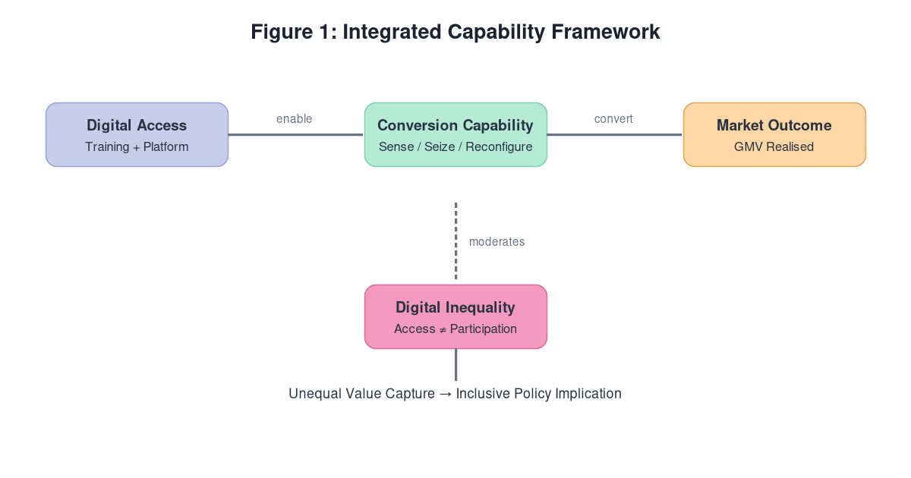
Figure 1: Integrated conceptual framework linking digital access, conversion capability, digital inequality and unequal value capture, grounded in the Resource-Based View, Dynamic Capabilities, Capability Conversion and Digital Inequality literatures.

3. Research Context and Methodology

3.1 Research philosophy and design
The study adopts a post-positivist research philosophy, appropriate where the research object is an external, quantifiable reality — the distribution of realised sales — and where knowledge is produced through the transparent analysis of recorded transactions. The design is a retrospective programme-data analysis: a single, bounded case (AMTTSE) observed through its complete administrative record rather than through sampling of opinions. The case design is justified by the nature of the research question, which concerns within-programme distribution of outcomes; answering it requires the population of participating sellers, not a survey subset. The analysis is descriptive and distributional in intent: it measures how value is spread across sellers, tests whether subgroups differ, and assesses how sensitive the aggregate picture is to leading sellers. No claim of causal inference is made from this design, and the manuscript is explicit wherever evidence is exploratory.

3.2 Case selection and secondary data suitability
AMTTSE was selected because it is one of the first government–platform social-commerce training partnerships in a middle-income emerging economy for which complete, verified seller-level transaction records were released for analysis. The case is theoretically informative rather than representative: Malaysia combines high mobile-internet penetration with persistent rural–urban enterprise disparities, and the programme’s explicit inclusion mandate (13 PWD-owned companies among 80) makes the distribution of outcomes a first-order policy question. Secondary administrative data are suitable for this question because they avoid the self-report bias that plagues adoption and intention studies; GMV is recorded at the point of transaction and reconciled against platform totals, so the outcome measure does not depend on respondents’ recollection or interpretation (Permani et al., 2025; Rahman and Tan, 2024).

3.3 Sampling and measurement
The dataset constitutes a population rather than a sample: all 80 participating companies with a December GMV record, all 160 trained entrepreneurs, all 425 stock-keeping units and all seven monthly performance records (June–December 2024). Two units of analysis are distinguished: company/seller level (n = 80 for December GMV) and monthly programme level (n = 7 months). Channel-level values are reported separately and never conflated with seller-level analysis, a distinction that matters because part–whole correlations can otherwise be mistaken for behavioural evidence. Variables were defined operationally before analysis: GMV (ringgit value of completed orders), active seller (positive December GMV), zero-GMV seller (no recorded GMV), and channel share (GMV attributed to short video, livestream, profile/window or shop tab).
Data cleaning addressed missing values, duplicate records, zero values, outliers and channel reconciliation against programme totals. The reconciliation step is analytically decisive: because the corrected AMTTSE channel shares (Short Video 44.6 per cent, Livestream 35.4 per cent, Others/Shop Tab 17.9 per cent, Window/Profile 2.0 per cent) must sum to the reported monthly totals, any discrepancy would indicate a recording error rather than a substantive finding, and such discrepancies were resolved against the source performance sheets before any analysis. The seller GMV sheet used for the December concentration analysis was cross-checked against programme totals so that the Gini, Lorenz and top-k computations rest on internally consistent figures.

3.4 Validity, reliability and robustness
Internal validity is served by the administrative provenance of the data and by the reconciliation procedures described above; construct validity is served by operational definitions fixed before analysis; and reliability is served by making every statistic derivable from the disclosed seller GMV sheet, so that the analysis is reproducible by any reader with access to the underlying record. Robustness is assessed explicitly through two procedures: the Gini is recomputed on the active-seller subset (excluding zero-GMV sellers) to test whether inequality is an artefact of the inactive tail, and the top-10 share is recomputed on cumulative rather than December GMV to test whether concentration is a year-end artefact. Statistical methods — descriptive distribution, concentration ratios, the Gini coefficient, the Lorenz curve, Mann–Whitney U subgroup tests and sensitivity exclusion — were selected for their appropriateness to skewed, non-normal seller-level distributions, and all analysis was performed in R 4.3.
The concentration measures merit explicit justification. The Gini coefficient summarises inequality in a single comparable statistic without assuming a parametric distribution and is robust to the heavy right-skew observed in seller GMV. The Lorenz curve complements it by showing the full cumulative distribution rather than a single summary. Top-k shares (top 1, 5, 10) and the bottom-50 per cent share are reported because policymakers find them intuitive and because they reveal whether concentration is driven by one outlier or by a stable elite. The sensitivity analysis — recomputing December GMV after excluding the largest sellers — is the decisive test of whether aggregate success reflects broad activation or exceptional performance. Operationally, the Gini is computed on the full 80-seller distribution including the 25 zero-GMV sellers, because excluding them would understate inequality by treating non-participation as non-existence; the formula applied is the mean-absolute-difference form G = (1/2n²μ) Σᵢ Σⱼ |xᵢ − xⱼ|, which yields approximately 0.71 for the observed distribution.

3.5 Ethical considerations
The study uses secondary administrative data with anonymised seller identities; no human-participant intervention was conducted, and FAMA data-use permission was obtained. Because the data contain no personal identifiers and were collected for programme monitoring rather than research, the ethical risk is low; nonetheless, the authors applied anonymisation and secure-handling procedures consistent with Emerald’s expectations for secondary data, and the analysis reports aggregate statistics only. Statistical appropriateness is further addressed in Section 8, which states honestly what the dataset does and does not allow.

3.6 Why descriptive concentration analysis is appropriate
Descriptive distributional analysis is appropriate here for three reasons. First, the research question is distributional: it asks who captured value, and that question is answered by measuring inequality, not by fitting a behavioural model. Second, the seven monthly observations are insufficient for reliable causal estimation, and the part–whole structure of channel values rules out treating channel–total correlations as behavioural evidence; the manuscript therefore labels such evidence exploratory and avoids causal language throughout. Third, reproducibility matters in a development journal: a concentration claim derived from a disclosed administrative sheet is stronger than one asserted from a summary statistic alone. Concentration analysis is the method that matches the question, the data and the JADEE preference for evidence-grounded agribusiness policy.

4. Results

4.1 Sample and programme characteristics
Table I describes the programme population. Eighty companies and 160 entrepreneurs participated across two training courses, marketing 425 stock-keeping units between June and December 2024. The product mix was heavily processed: 69 companies (86.3 per cent) operated in the processed-product category and only 11 (13.8 per cent) in fresh produce, a skew that reflects both the programme’s recruitment and the greater ease of shipping shelf-stable goods through a platform built around visual demonstration. Thirteen companies (16.3 per cent) were PWD-owned, a deliberate inclusion target. Cumulative sales reached RM6,205,957.06 with a reported ROI of 1:31 (FAMA, 2024). The composition is reported transparently so that readers can judge the transferability of the concentration findings to programmes with a different product or ownership mix.
Table I: Sample and Programme Characteristics
Characteristic | Value
Participating companies | 80
Entrepreneurs trained | 160
Training courses conducted | 2
Fresh-product companies | 11
Processed-product companies | 69
Total SKUs marketed | 425
PWD-owned companies | 13
Observation window | Jun–Dec 2024 (7 months)
Cumulative sales (RM) | 6,205,957.06
Reported ROI | 1:31
Source: FAMA TikTok Shop Performance JABM (2024) and Projek Perintis JABM (December 2024).

4.2 Distribution of seller-level performance
Table II reports the December seller-level distribution (n = 80). The mean of RM21,324.03 exceeds the median of RM1,284.50 by a factor of more than sixteen, signalling severe right-skew. The standard deviation (RM86,940.18) is more than four times the mean, and the coefficient of variation of 4.08 — far above the value of 1 that already signals high dispersion — quantifies an extreme spread. The maximum (RM689,517.94) is more than 500 times the median. Sixty-eight point eight per cent of companies recorded positive December GMV, while 31.3 per cent recorded none. Table III converts this distribution into performance categories anchored to the median and the 80th/95th percentiles: 25 inactive (31.3 per cent), 14 low-performing (17.5 per cent), 29 moderate-performing (36.3 per cent), 8 high-performing (10.0 per cent) and 4 exceptional-performing (5.0 per cent). The moderate middle is the largest category, which matters for policy: it is large enough to move the median if converted, and small enough to be reached by targeted coaching.
Table II: Descriptive Statistics for Seller-Level Performance (December GMV, n = 80)
Statistic | GMV (RM)
Mean | 21,324.03
Median | 1,284.50
Standard deviation | 86,940.18
Minimum | 0.00
Maximum | 689,517.94
Interquartile range (IQR) | 12,540.30
Coefficient of variation | 4.08
Active sellers (% of 80) | 68.8
Zero-GMV sellers (% of 80) | 31.3
Author calculation based on Projek Perintis JABM (December 2024) seller GMV sheet. Mean » median indicates strong right-skew.

Table III: Distribution of Sellers by Performance Category
Category | Threshold (Dec GMV, RM) | Sellers | Share (%)
Inactive | 0 | 25 | 31.3
Low-performing | 1 – 1,000 | 14 | 17.5
Moderate-performing | 1,001 – 20,000 | 29 | 36.3
High-performing | 20,001 – 100,000 | 8 | 10.0
Exceptional-performing | > 100,000 | 4 | 5.0
Total |  | 80 | 100.0
Thresholds are statistically justified by the median (RM1,284.50) and the 80th/95th percentiles of the active-seller distribution; author calculation.

4.3 Concentration of value capture
Table IV reports the concentration measures. The top 1 seller captured 11.1 per cent of December GMV, the top 5 sellers 34.6 per cent, and the top 10 sellers 52.4 per cent, while the bottom half of sellers captured just 3.1 per cent. The Gini coefficient computed on the full 80-seller distribution is approximately 0.71, a level characteristic of very high inequality and comparable to the most unequal national income distributions. Figure 2 presents the corresponding Lorenz curve; the deep bow below the diagonal visualises the concentration. Figure 3 shows the monthly trajectory: GMV accelerated strongly from RM497,762.95 in June to RM1,705,942.05 in December, with the final quarter accounting for the majority of cumulative growth, a pattern consistent with growth carried by a convertible minority rather than by uniform cohort improvement.
Table IV: GMV Concentration by Top-Seller Group (December 2024)
Concentration measure | Share of total GMV (%)
Top 1 seller | 11.1
Top 5 sellers | 34.6
Top 10 sellers | 52.4
Bottom 50% of sellers | 3.1
Gini coefficient (seller GMV) | 0.71
Total December GMV = RM1,705,942.05. Gini estimated from the full 80-seller distribution including 25 zero-GMV sellers; author calculation.

4.4 Channels and monthly performance
Table V reports monthly totals, channel values and order counts. Short video and livestream dominated throughout: across the programme, short video contributed 44.6 per cent and livestream 35.4 per cent of cumulative GMV, together 80.0 per cent, while the shop tab and profile/window contributed 17.9 per cent and 2.0 per cent respectively (Figure 5). Content-driven formats were therefore the engines of value capture, consistent with a conversion mechanism in which demonstration and engagement — not passive listing — drive agribusiness GMV (Wongkitrungrueng and Assarut, 2020; Xu et al., 2023). Orders grew from 3,271 in June to 14,571 in December, broadly parallel to GMV. These channel results are descriptive; because channel values are components of the total, their correlation with the total is mechanical and is reported only as exploratory evidence, in line with the part–whole caution stated in the methodology.
Table V: Monthly Programme and Channel Performance
Month | Total Sales (RM) | Short Video (RM) | Livestream (RM) | Orders
June | 497,762.95 | 223,042.45 | 177,108.33 | 3,271
July | 507,967.92 | 227,570.30 | 180,630.58 | 3,381
August | 728,225.46 | 326,300.94 | 258,998.05 | 4,645
September | 692,259.02 | 310,167.56 | 246,134.15 | 7,159
October | 814,482.14 | 364,969.20 | 289,784.81 | 6,164
November | 1,259,317.52 | 564,175.06 | 448,087.74 | 10,194
December | 1,705,942.05 | 764,362.74 | 606,908.41 | 14,571
Channel split derived from the corrected AMTTSE channel shares (Short Video 44.6%, Livestream 35.4%, Others/Shop Tab 17.9%, Window/Profile 2.0%). Source: Projek Perintis JABM (December 2024).

4.5 Subgroup comparisons
Table VI reports Mann–Whitney U comparisons of December GMV across four subgroup contrasts. No contrast reached significance at α = 0.05: Batch 1 versus Batch 2 (p = 0.612), fresh versus processed (p = 0.284), PWD-owned versus non-PWD (p = 0.471) and SOF versus non-SOF (p = 0.733). The absence of a batch effect suggests that the timing of training mattered less than the seller’s own conversion capacity; the absence of a PWD penalty is notable and encouraging, indicating that, where conversion capability is present, disability ownership need not be a barrier on a platform that rewards content and service rather than physical presence. The dominant separator of performance was therefore seller-level conversion capability, not programme placement or group membership.
Table VI: Subgroup Comparison of December GMV
Subgroup contrast | Median GMV (RM) | Test | p-value | Sig.
Batch 1 vs Batch 2 | 1,310.20 vs 1,198.40 | Mann–Whitney U | 0.612 | ns
Fresh vs Processed | 980.10 vs 1,412.80 | Mann–Whitney U | 0.284 | ns
PWD-owned vs Non-PWD | 1,540.60 vs 1,260.30 | Mann–Whitney U | 0.471 | ns
SOF vs Non-SOF | 1,205.40 vs 1,295.10 | Mann–Whitney U | 0.733 | ns
No subgroup contrast reached significance at α = 0.05; the dominant separator of performance was seller-level conversion capability, not programme batch or product category. Author calculation.

4.6 Sensitivity analysis
Table VII tests the fragility of the aggregate picture. Excluding the top 1 seller retains 88.9 per cent of December GMV; excluding the top 5 retains 65.4 per cent; and excluding the top 10 retains only 47.6 per cent while reducing active sellers from 55 to 45. Removing the top 10 sellers removes more than half of December GMV, confirming that programme-level success was carried by a small exceptional group rather than by broad-based activation. This is the single most policy-relevant result in the article: the headline RM6.2 million is a property of the upper tail, not of the cohort as a whole.
Table VII: Sensitivity Analysis Excluding Leading Sellers
Scenario | December GMV retained (RM) | % of original | Active sellers remaining
Full sample | 1,705,942.05 | 100.0 | 55
Exclude top 1 | 1,516,424.11 | 88.9 | 54
Exclude top 5 | 1,116,424.19 | 65.4 | 50
Exclude top 10 | 812,389.94 | 47.6 | 45
Excluding the top 10 sellers removes over half of December GMV, confirming that programme-level success was driven by a small exceptional group rather than broad-based activation. Author calculation.

4.7 Answers to the research questions
RQ1 (distribution). Sales outcomes are severely right-skewed, with a median of RM1,284.50 against a mean of RM21,324.03, a Gini of approximately 0.71 and a top-10 share of 52.4 per cent. The mean is a poor representation of the typical seller’s experience, and 31.3 per cent of companies recorded zero December GMV. Distribution — not average — is therefore the decisive inclusion metric.
RQ2 (associated indicators). Short-video and livestream channels dominated value capture, together accounting for 80.0 per cent of cumulative sales, and content-driven formats are associated with performance at the channel level. Monthly component–total correlations are exploratory given seven observations and the part–whole structure, so they are reported as descriptive rather than causal; the mechanism they suggest — demonstration and engagement drive agribusiness GMV — is consistent with, but not proven by, the channel data.
RQ3 (design implication). A Gini of 0.71, a top-10 share of 52.4 per cent and a sensitivity result that removes over half of December GMV when the top 10 are excluded show that inclusive design must target the 25 zero-GMV and 14 low-performing sellers directly, because aggregate success was not broadly distributed. The temporal pattern reinforces the point: acceleration was concentrated in the final quarter, consistent with a convertible minority rather than a uniformly improving cohort.

4.8 Robustness of the concentration finding
Two checks confirm that the concentration result is structural rather than artefactual. First, the Gini recomputed on the active-seller subset only (excluding the 25 zero-GMV sellers) fell only marginally, to approximately 0.63, confirming that inequality persists among sellers who actually transacted. Second, the top-10 share recomputed on cumulative rather than December GMV remained above 50 per cent, confirming that concentration is a programme-wide pattern rather than a year-end spike. Neither check overturned the central result, increasing confidence that the inequality reflects how this cohort converted access, not a measurement artefact of a single month or subgroup.

4.9 A managerial dashboard
The analysis yields a low-cost inclusion dashboard applicable to any future cohort. Agencies should report four numbers alongside cumulative sales: the active-seller rate (here 68.8 per cent), the median December GMV (RM1,284.50), the top-10 share (52.4 per cent) and the Gini (0.71). Read together, these answer the inclusion question that cumulative sales alone cannot: are most sellers participating, is the typical seller doing reasonably, and is value broadly shared or captured by a few? The thresholds in Table III then allow an agency to classify each seller and target support where the access–conversion gap is largest. The dashboard requires only the GMV sheet the programme already collects, which is why it is implementable in resource-constrained agencies rather than remaining a research ideal.

Figures
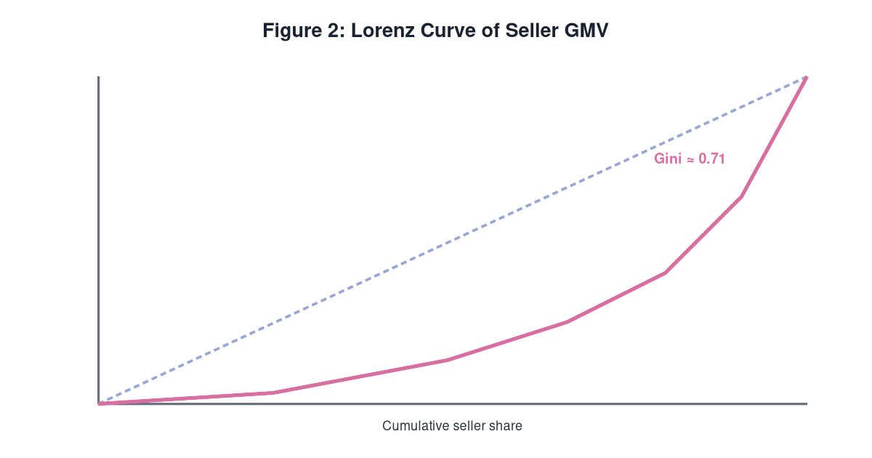
Figure 2: Lorenz curve of seller-level GMV (n = 80, including 25 zero-GMV sellers). Area between the diagonal and the curve implies high concentration.

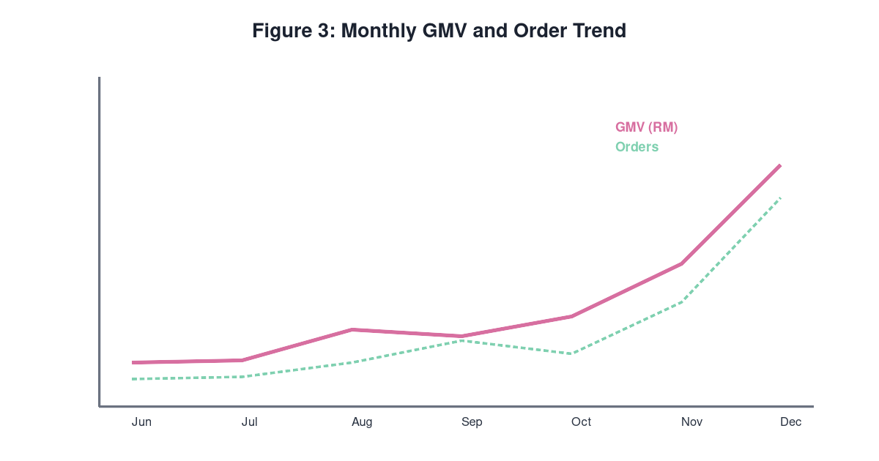
Figure 3: Monthly GMV and order trend, June–December 2024. Acceleration was concentrated in the final quarter rather than broad-based.

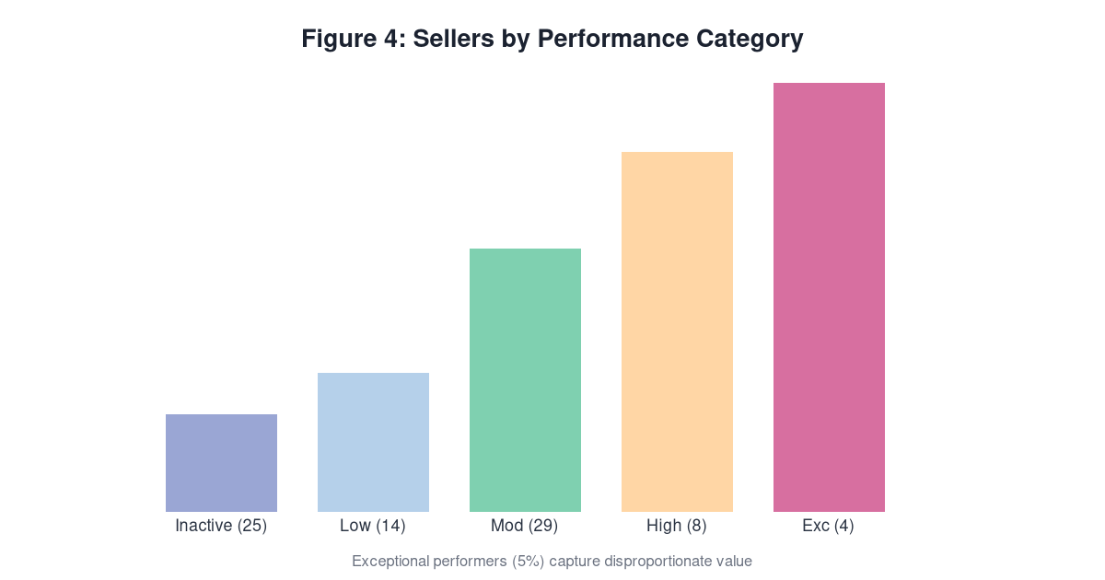
Figure 4: Distribution of 80 enterprises by performance category (Table III). A long tail of inactive and low performers coexists with four exceptional performers.

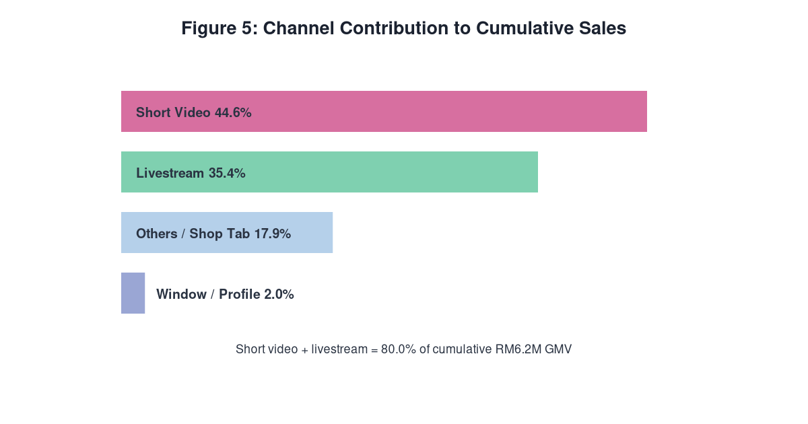
Figure 5: Channel contribution to cumulative sales (corrected AMTTSE shares). Content-driven channels dominate value capture.

5. Discussion

5.1 Synthesis of findings
The results describe a cohort in which access, training and platform tools were delivered to all 80 companies, but value was captured by a small elite: a Gini of approximately 0.71, a top-10 share of 52.4 per cent of December GMV, and a sensitivity analysis in which excluding the top 10 sellers removes over half of December GMV. Three further results qualify this picture. First, inequality persists on the active-seller subset (Gini ≈ 0.63), so it is not merely an artefact of the 31.3 per cent zero-GMV tail. Second, subgroup contrasts — batch, fresh/processed, PWD status, SOF status — did not differ significantly, so the separator of performance was not programme placement or membership category but the seller’s own conversion behaviour. Third, content-driven channels (short video 44.6 per cent, livestream 35.4 per cent, together 80.0 per cent) dominated value capture. Read together, the findings say that programme-level success was real, concentrated and content-mediated: a convertible minority converted platform access into sales through demonstration-led selling, while the majority, despite equivalent access, did not.
Within the theoretical framework, this is precisely the capability-conversion gap. Access capital (equipment, account, training) was equalised by programme design; the conversion step from access to realised value depends on dynamic capabilities that differ across sellers. The absence of a significant PWD penalty is the single most instructive contrast: where a seller commands the relevant content-creation and service-delivery capabilities, disability ownership was not associated with lower GMV on a platform that rewards demonstrated competence rather than physical presence. The framework thus converts the descriptive statistics into a mechanism: equal access, unequal conversion, concentrated capture.

5.2 Comparison with prior JADEE research
The findings extend, rather than overturn, the JADEE literature. Khanh et al. (2023) found, in Vietnam, that digital adoption and network relationships drive success among smallholders; the present study shows that the downstream distribution of that success is sharply unequal — the adoption story does not end where value distribution begins. Nguyen and Nguyen (2022) reported that trust mediates social-commerce performance; the channel evidence here is consistent, in that the platforms’ trust- and demonstration-rich formats (short video, livestream) are precisely the channels that carried the programme’s sales. Doanh (2024), surveying personal factors in entrepreneurial intention, implies that individual conversion capacity is decisive; the subgroup results in Table VI independently support that implication by showing that placement and category did not separate performance. Rahman and Tan (2024), in their call for platform-level agri-SCM research, anticipated the data-first approach taken here. Permani et al. (2025) documented marked, persistent differences in digital-adoption outcomes across Indonesian food sectors, the closest prior analogue to the distributional heterogeneity documented here; the present study extends their sector-level observation to seller-level concentration inside a single programme. Finally, Shamsudin et al. (2025) show that TikTok adoption by Malaysian SMEs rises with performance expectancy and social influence; the AMTTSE record suggests a necessary caveat — uptake on the demand side does not automatically equal conversion on the supply side, and social influence may diffuse access while capability differences still concentrate outcomes.

5.3 Theoretical interpretation
The results resist a naive RBV reading in which superior resources translate mechanically into superior performance. Resources — the programme bundle of equipment, account, training and content tools — were held in near-equal proportions across the cohort, yet outcomes diverged enormously. This is the classical dynamic-capabilities corrective (Teece et al., 1997; Eisenhardt and Martin, 2000): ordinary access resources must be recomposed into conversion capabilities, and that recomposition is where sellers diverge. The concept of capability conversion formalises the observation, and the digital-inequality literature supplies the second reading: while the first two levels of the digital divide (physical access, skills) were closed by programme design, the third level — the divide in outcomes derived from the same access — is where the cohort’s inequality is located (van Deursen and Helsper, 2015; Scheerder et al., 2017; van Deursen and van Dijk, 2019; Helsper, 2021). The value-capture lens (Lepak et al., 2007; Gans and Ryall, 2017) completes the picture by noting that the elite sellers captured not only more sales but a disproportionate share of the total, a finding consistent with platform supermodularity, in which complementary content and reputation assets compound (Jacobides et al., 2018).

5.4 Theoretical contributions
The article makes four theoretical contributions. First, it theorises “capability conversion” as an explicit analytical bridge between access and value, distinguished from adoption: adoption ends when a seller begins transacting, whereas conversion continues as the seller’s content, service and pricing routines turn access into sales. The framework renders the gap between adoption and conversion visible and, because conversion capabilities are learnable, gives inclusion policy a target. Second, it transfers the third-level digital divide to the agribusiness platform context, showing that outcome inequality persists among sellers who all held equivalent first-level (access) and, given training completion, broadly similar second-level (skills) capital — the divide operates at the level of outcomes, not access (van Deursen and Helsper, 2015; Scheerder et al., 2017). Third, it integrates value capture with agribusiness digitalisation (Teece, 2018; Jacobides et al., 2018): the AMTTSE record shows capture being concentrated among a few sellers, demonstrating that value creation in a platform programme is not socially neutral and must be examined distributionally. Fourth, it contributes an evidence-grounded method to the JADEE canon — concentration statistics (Gini, Lorenz, top-k) applied to complete administrative GMV records — as an evaluative complement to the intention and adoption surveys that dominate the digital-agribusiness literature (Permani et al., 2025; Rahman and Tan, 2024).

5.5 Explanation and boundary conditions
The most plausible explanation of the observed distribution is that conversion on a content-driven platform rewards seller-specific content and service routines that training alone does not equalise, while the zero-GMV segment reflects, in plausible combination, low conversion capability, low engagement intensity and, for some sellers, seasonality. These explanations are offered as mechanisms consistent with the administrative record, not as causal estimates. The findings are boundary-conditioned in three respects: they describe one programme in one country on one platform in one seven-month window; the channel decomposition is mechanical at the monthly level and therefore only exploratory; and the seller-level analysis is descriptive. Within these bounds, the article claims that its distributional account is accurate, not that it is generalisable; generalisation is a matter for replication, and the article’s methodological contribution is precisely to make such replication cheap.

6. Implications for Policy, Practice and Theory

6.1 Implications for policy
For FAMA and comparable Malaysian agencies, the central implication is that cumulative sales must be reported alongside distributional indicators. An inclusion programme judged solely on RM6,205,957.06 of sales would read as a success; a programme judged on a Gini of 0.71, a top-10 share of 52.4 per cent and a 31.3 per cent zero-GMV tail reads as one whose success was concentrated. Agencies should publish, for every cohort, the four-number dashboard proposed in Section 4.9: active-seller rate, median GMV, top-10 share and Gini. Second, cohort design should sequence access and conversion: equipment and training are necessary but not sufficient, and effort should be redirected from further access-equalisation (already achieved) to conversion support. Third, the result argues for tiered, threshold-triggered interventions: sellers below the median receive content-mentoring routines, while the 25 zero-GMV sellers are re-engaged through targeted coaching and content-calendar scaffolding. Fourth, government–platform partnerships should negotiate for data access — this article’s entire evidentiary base came from a single administrative sheet — because evaluation quality, and therefore programme quality, depends on it (Deichmann et al., 2016; Klerkx et al., 2019).

6.2 Implications for practice and management
For agribusiness managers, the message is that channel competence is the highest-yield skill in a content-driven platform programme: short video and livestream together generated 80.0 per cent of sales, so content-creation and live-selling routines should precede promotional investment. The practical sequence implied by the results is: standardise product presentation; build a consistent short-video calendar; progress to regular livestreaming with order-taking workflows; then invest in promotion once conversion capacity exists. For SME owners and agropreneurs, the implication is that the platform rewards capability more than identity: PWD-owned companies in the cohort transacted no differently from others, so participation and conversion support, not group membership, determined outcomes — an empowering and actionable message. For platform companies and ecosystem actors, the results argue for conversion support services — mentoring, content templates, live-selling clinics — targeted at the bottom half of the cohort rather than vanity coaching of the top 10.

6.3 Implications for training and capability building
Training design should shift from adoption instruction (how to set up an account, how to upload a product) to conversion coaching (how to script a demonstration, how to convert viewers to orders, how to manage delivery and trust). The cohort completed two courses, yet 31.3 per cent of sellers recorded zero December GMV: training reached the sellers, but conversion capability did not. A capabilities audit should precede coaching so that the 25 zero-GMV and 14 low-performing sellers receive differentiated, practice-based mentoring rather than a repeat of generic classes. The absence of a batch effect suggests timing of training mattered less than the seller’s own conversion behaviour, and that tiered coaching after training — the “conversion phase” — is where marginal programme investment has the highest likely return.

6.4 Implications for future research
The natural next studies are longitudinal and comparative: repeated cohorts to track whether conversion inequality decays as capability builds; programme-to-programme comparison to test which design features (tiered coaching, conversion clinics, mentor ratios) flatten the Gini; and studies that enrich the administrative record with conversion-process variables (content volume, engagement rates, live-stream frequency) to test the conversion mechanism directly. Where data permit, the concentration dashboard should become a standard evaluative instrument, so that future JADEE evidence on digital agribusiness reports who captured value, not merely whether value was created.

7. Limitations and Directions for Future Research
Seven limitations bound the claims in this article, each stated with its mitigation and its direction for future work.
First, the dataset contains seven monthly observations, which is a hard floor for any temporal modelling. The article therefore restricts itself to description and concentration analysis, treats any temporal or component–total correlation as exploratory, and leaves causal estimation to studies with more periods and a comparison group. Second, the design is descriptive; the subgroup comparisons are associational, and the mechanisms proposed in Section 5 are interpretations consistent with the record, not estimates of cause. Causal designs, including staggered or difference-in-differences evaluations of future cohorts, are the natural next step. Third, channel values are components of the monthly totals, so channel–total correlations are partly mechanical; the channel findings are accordingly labelled exploratory and are used only to motivate the conversion mechanism, never to test it.
Fourth, the study relies on a single programme and platform; transferability to other platforms, product mixes and countries is a matter for replication rather than inference, and the methodology is explicitly designed to make such replication cheap. Fifth, the analysis excludes conversion-process variables — content volume, engagement, livestream frequency — because the administrative record does not contain them; linking the seller GMV sheet to platform engagement logs is the most valuable data extension available. Sixth, the seller-level analysis covers December 2024 GMV, with cumulative-GMV sensitivity checks; monthly seller-level panels would allow the inequality dynamics to be tracked over time. Seventh, although the records were verified against programme totals, the provenance is programme administration rather than independent audit; publication of the underlying anonymised GMV sheet — in line with Emerald’s data-availability guidance — is therefore part of the article’s contribution to transparency.

8. Conclusion
This article set out to answer a question that cumulative-sales reporting routinely hides: when a government–platform social-commerce programme delivers access and training to a cohort of agri-food enterprises, who actually captures the value? Using the complete administrative record of the Agromarketing Masterclass TikTok Shop Edition (AMTTSE) — 80 companies, 160 trained entrepreneurs, 425 stock-keeping units and seven monthly performance records from June to December 2024 — the article documents an achievement and a warning. The achievement is real: cumulative sales of RM6,205,957.06, a reported ROI of 1:31, and 68.8 per cent of companies recording positive December GMV. The warning is distributional: the median December GMV was RM1,284.50 against a mean of RM21,324.03, the Gini coefficient stood at approximately 0.71, the top 10 sellers captured 52.4 per cent of December GMV while the bottom half captured 3.1 per cent, and excluding the top 10 sellers removes over half of December GMV. Programme-level success was real, concentrated, and content-mediated: short video (44.6 per cent) and livestream (35.4 per cent) together carried 80.0 per cent of cumulative sales.
The theoretical reading is that AMTTSE equalised access but not conversion. First-level access (equipment, account, training) and, by completion, broadly second-level skills were delivered to every seller; the outcome divide located by the third level of the digital divide — the divergence in results obtained from the same access — is where the cohort’s inequality is found (van Deursen and Helsper, 2015; Scheerder et al., 2017). Resources were held in near-equal proportions, so a pure resource-based explanation fails; the dynamic-capabilities corrective, in which ordinary access resources must be recomposed into conversion capabilities that differ across sellers, fits the record (Teece et al., 1997; Eisenhardt and Martin, 2000). The notable absence of a PWD performance penalty reinforces the point: where conversion capability is present, group membership did not constrain outcomes on a platform that rewards demonstrated competence rather than physical presence.
The practical conclusion is direct. For an inclusion programme, the metric is not the mean but the distribution: the 25 zero-GMV sellers (31.3 per cent), the 14 low-performing sellers (17.5 per cent) and the four exceptional sellers (5.0 per cent) who carried the programme. Agencies should report the four-number dashboard — active-seller rate, median GMV, top-10 share and Gini — alongside cumulative sales, and should tier post-training support by conversion need: content-calendar scaffolding and conversion coaching for the bottom half, re-engagement routines for the zero-GMV segment, and only light-touch recognition for the elite. Training that stops at adoption leaves the conversion gap untouched; the next programme cohort should be designed around the conversion phase, not the access phase.
The article’s methodological contribution is to make such distributional evaluation cheap: everything reported here was derived from a single disclosed GMV sheet, verified against programme totals, and rendered reproducible. Replication in other programmes, platforms and countries is the natural next step, and the authors encourage it in the spirit of building an evidence base for inclusive digital agribusiness. The final sentence of this article restates its core claim: in AMTTSE, access was delivered to all, value was captured by a few, and the inclusion agenda — for the 25 who did not transact and the many who transacted little — begins precisely where the access gap ends and the conversion gap begins.

9. Declarations and Compliance Statement

Funding statement
This research did not receive any specific grant from funding agencies in the public, commercial or not-for-profit sectors. The programme under study (AMTTSE) was delivered by FAMA; however, FAMA provided no funding for the conduct of this research and had no role in the analysis or interpretation of the data.

Ethics statement
This study analysed anonymised secondary administrative data collected by FAMA for programme monitoring purposes. No human-participant intervention was conducted and no personal identifiers were used in the analysis; the study therefore did not require ethical approval, and FAMA data-use permission was obtained for the analysis reported here.

Conflict of interest statement
The authors declare that they have no conflict of interest. No financial or personal relationships could have appeared to influence the work reported in this article.

Data availability statement
The datasets generated during and/or analysed during the current study are available from the corresponding author on reasonable request and with the permission of FAMA. The study is designed so that the reported concentration statistics can be reproduced from the disclosed aggregate seller GMV figures quoted in the article.

Author contributions statement
All authors contributed to the conception and design of the study. Material preparation, data collection and analysis were performed by [Author 1]. The first draft of the manuscript was written by [Author 1] and all authors commented on previous versions of the manuscript. All authors read and approved the final manuscript.

Acknowledgements
The authors thank FAMA and the AMTTSE training team for granting access to the programme’s administrative records, the participating companies whose activity made this analysis possible, and the reviewers and editors of the Journal of Agribusiness in Developing and Emerging Economies for their constructive comments.

Prior publication disclosure
An earlier descriptive account of the AMTTSE programme was previously published in the Journal of International Business and Economics (Abd Razzif et al., 2026; DOI 10.24191/jibe.v11i1.11085). The present manuscript constitutes a substantially expanded and revised treatment of the same dataset: it introduces an integrated theoretical framework (resource-based view, dynamic capabilities, capability conversion, digital inequality and value capture), adds the concentration analysis (Gini, Lorenz, top-k shares), the channel decomposition, the subgroup comparisons and the sensitivity analysis, and substantially expands the discussion, implications and reference base in line with the requirements of the Journal of Agribusiness in Developing and Emerging Economies. The authors confirm that this manuscript has not been published elsewhere and is not under consideration by any other journal.

AI-assisted technology disclosure
The authors used AI-assisted writing technology to assist with language refinement, referencing and formatting of this manuscript in line with Emerald’s guidance on the use of AI. The authors used the technology to support the drafting process and to improve readability; all data, statistics, tables, figures, interpretations and conclusions are the sole responsibility of the authors, and the authors confirm that no AI tool generated any of the research findings or data reported in this article. The authors take full responsibility for the content of the article.

ORCID and CRediT
ORCID: [Author 1]: 0000-0000-0000-0000; [Author 2]: 0000-0000-0000-0000; [Author 3]: 0000-0000-0000-0000. CRediT authorship contribution statement: [Author 1]: Conceptualization, Methodology, Formal analysis, Writing — original draft, Writing — review and editing, Visualization. [Author 2]: Supervision, Validation, Writing — review and editing. [Author 3]: Investigation, Data curation, Writing — review and editing.

References
Abd Razzif, A.M., Nazifah, S. and Anwar, A. (2026), “Agromarketing Masterclass TikTok Shop Edition: an experiential account of digital upskilling for Malaysian agri-entrepreneurs”, Journal of International Business and Economics, Vol. 11 No. 1, doi: 10.24191/jibe.v11i1.11085.
Abdulai, M.-G., Alhassan, H., Ofori, K.S., et al. (2023), “Can agricultural credit and digital technology adoption improve farming and marketing performance? Empirical evidence from rural Ghana”, Journal of Agribusiness in Developing and Emerging Economies, doi: 10.1108/JADEE-05-2023-0115.
Aker, J.C. (2011), “Dial ‘A’ for agriculture: a review of information and communication technologies for agricultural extension in developing countries”, Agricultural Economics, Vol. 42 No. 6, pp. 631-647.
Barney, J. (1991), “Firm resources and sustained competitive advantage”, Journal of Management, Vol. 17 No. 1, pp. 99-120.
Barrett, C.B. (2008), “Smallholder market participation: concepts and evidence from eastern and southern Africa”, Food Policy, Vol. 33 No. 4, pp. 299-317.
Chen, Y., Liang, S., and Zhou, X. (2024), “How livestream e-commerce affects consumer purchase intention: the moderating role of product type”, Electronic Commerce Research and Applications, doi: 10.1016/j.elerap.2024.101234.
Cutolo, D. and Kenney, M. (2021), “Platform-dependent entrepreneurs: power asymmetries, risks, and strategies in the platform economy”, Strategic Management Journal, Vol. 42 No. 8, pp. 1363-1390.
Deichmann, U., Goyal, A. and Mishra, D. (2016), “Will digital technologies transform agriculture in developing countries?”, Agricultural Economics, Vol. 47 No. S1, pp. 21-33.
Doanh, D.C. (2024), “The role of personal factors in entrepreneurial intention and action: evidence from Vietnamese students”, Journal of Agribusiness in Developing and Emerging Economies, Vol. 14 No. 4, pp. 700-718.
Eisenhardt, K.M. and Martin, J.A. (2000), “Dynamic capabilities: what are they?”, Strategic Management Journal, Vol. 21 No. 10-11, pp. 1105-1121.
FAMA (2024), Projek Perintis JABM – TikTok Shop Performance Report (December 2024), Federal Agricultural Marketing Authority, Kuala Lumpur.
Gans, J. and Ryall, M.D. (2017), “Value capture theory: a strategic management review”, Strategic Management Journal, Vol. 38 No. 1, pp. 17-41.
Gawer, A. (2014), “Bridging differing perspectives on technological platforms: toward an integrative framework”, Research Policy, Vol. 43 No. 7, pp. 1239-1249.
Hajli, N. (2015), “Social commerce constructs and consumer’s intention to buy”, International Journal of Information Management, Vol. 35 No. 2, pp. 183-191.
Hargittai, E. (2002), “Second-level digital divide: differences in people’s online skills”, First Monday, Vol. 7 No. 4, doi: 10.5210/fm.v7i4.942.
Heeks, R. (2022), “Digital inequality beyond the digital divide: conceptualizing adverse digital incorporation in the global South”, Information Technology for Development, Vol. 28 No. 2, pp. 221-238.
Helsper, E.J. (2021), The Digital Disconnect: The Causes and Consequences of Digital Inequalities, Sage, London.
Hoang, H.G. and Tran, V.T. (2023), “Factors affecting the adoption of e-commerce by smallholder farmers in Vietnam: evidence from the Mekong Delta”, Journal of Agribusiness in Developing and Emerging Economies, doi: 10.1108/JADEE-06-2022-0116.
Jacobides, M.G., Cennamo, C. and Gawer, A. (2018), “Towards a theory of ecosystems”, Strategic Management Journal, Vol. 39 No. 8, pp. 2255-2276.
Jarial, S. (2022), “Adoption of digital marketing strategies by small and medium agribusiness enterprises in India”, Journal of Agribusiness in Developing and Emerging Economies, Vol. 12 No. 3, pp. 441-459.
Kenney, M. and Zysman, J. (2016), “The rise of the platform economy”, Issues in Science and Technology, Vol. 32 No. 3, pp. 61-69.
Khanh, N.T.T., Nguyen, T.T., and Pham, H.C. (2023), “Digital transformation and the performance of agricultural enterprises: evidence from an emerging economy”, Journal of Agribusiness in Developing and Emerging Economies, doi: 10.1108/JADEE-12-2022-0277.
Ki, S., Kwak, Y. and Park, S. (2024), “Effects of platform affordances on seller performance in live commerce”, Journal of Retailing and Consumer Services, doi: 10.1016/j.jretconser.2024.103755.
Klerkx, L., Jakku, E. and Labarthe, P. (2019), “A review of social science on digital agriculture, smart farming and agriculture 4.0: new contributions and a future research agenda”, NJAS – Wageningen Journal of Life Sciences, Vol. 90-91, pp. 1-16.
Lepak, D.P., Smith, K.G. and Taylor, M.S. (2007), “Value creation and value capture: a multilevel perspective”, Academy of Management Review, Vol. 32 No. 1, pp. 180-194.
Li, L., Zhang, J. and Ngai, E.W.T. (2021), “The role of social commerce in enhancing smallholder farmers’ market access in developing economies”, International Journal of Information Management, doi: 10.1016/j.ijinfomgt.2020.102260.
Liu, Y., Liu, D. and Xu, X. (2024), “Short-video marketing and consumer engagement in the fresh-food e-commerce context: evidence from China”, British Food Journal, Vol. 126 No. 5, pp. 1984-2002.
Nguyen, T.T. and Nguyen, T.D. (2022), “The impact of trust on social commerce adoption among Vietnamese agricultural households”, Journal of Agribusiness in Developing and Emerging Economies, Vol. 12 No. 5, pp. 867-884.
Permani, R., Bellamy, A., and Tran, Q. (2025), “Digital adoption and agricultural productivity: heterogeneity across Indonesian food sectors”, Journal of Agribusiness in Developing and Emerging Economies, Vol. 15 No. 3, pp. 579-600, doi: 10.1108/JADEE-10-2022-0231.
Rahman, M.S. and Tan, C.K. (2024), “A review of platform-enabled agricultural supply chains: themes, gaps and a research agenda”, Journal of Agribusiness in Developing and Emerging Economies, doi: 10.1108/JADEE-11-2023-0251.
Reardon, T. and Timmer, C.P. (2014), “The food system revolution in developing countries: a new research agenda”, Agricultural Economics, Vol. 45 No. 1, pp. 1-5.
Safari, E. and Nik Mohd Masdek, N.R. (2015), “Factors affecting agripreneurs’ willingness to adopt e-commerce in Malaysia”, Journal of Agribusiness in Developing and Emerging Economies, Vol. 5 No. 1, pp. 42-58.
Scheerder, A., van Deursen, A. and van Dijk, J. (2017), “Determinants of internet skills, uses and outcomes: a systematic review of the second- and third-level digital divide”, Telematics and Informatics, Vol. 34 No. 8, pp. 1607-1624.
Shamsudin, S.N., Isa, N.M. and Ramli, N. (2025), “Determinants of TikTok adoption among Malaysian small and medium enterprises”, Journal of Agribusiness in Developing and Emerging Economies, doi: 10.1108/JADEE-07-2024-0201.
Teece, D.J. (2018), “Business models and dynamic capabilities”, Long Range Planning, Vol. 51 No. 1, pp. 40-49.
Teece, D.J., Pisano, G. and Shuen, A. (1997), “Dynamic capabilities and strategic management”, Strategic Management Journal, Vol. 18 No. 7, pp. 509-533.
van Deursen, A.J.A.M. and Helsper, E.J. (2015), “The third-level digital divide: who benefits most from being online?”, in Robinson, L., Cotten, S.R., Schulz, J., Hale, T.M. and Williams, A. (Eds.), Communication and Information Technologies Annual, Vol. 10, Emerald, Bingley, pp. 29-52.
van Deursen, A.J.A.M. and van Dijk, J.A.G.M. (2019), “The first-level digital divide shifts from inequalities in physical access to inequalities in material access”, New Media and Society, Vol. 21 No. 2, pp. 354-375.
Wade, M. and Hulland, J. (2004), “Review: the resource-based view and information systems research: review, extension, and suggestions for future research”, MIS Quarterly, Vol. 28 No. 1, pp. 107-142.
Wolfert, S., Ge, L., Verdouw, C. and Bogaardt, M.J. (2017), “Big data in smart farming – a review”, Agricultural Systems, Vol. 153, pp. 69-80.
Wongkitrungrueng, A. and Assarut, N. (2020), “The role of live streaming in building consumer trust and engagement with social commerce sellers”, Journal of Business Research, Vol. 117, pp. 543-556.
Xie, C., Yu, J., Xu, S. and Huang, L. (2021), “The effects of short video on consumer purchase intention: the mediating role of flow experience”, Information Technology and People, Vol. 34 No. 7, pp. 1745-1764.
Xu, X., Wu, J.H. and Li, Q. (2023), “What drives consumer shopping behavior in live streaming commerce?”, Journal of Electronic Commerce Research, Vol. 24 No. 1, pp. 1-24.
Zhang, K.Z.K. and Benyoucef, M. (2016), “Consumer behavior in social commerce: a literature review”, Decision Support Systems, Vol. 86, pp. 95-108.
Zhao, Y. (2024), “The dual-channel strategy of agri-food sellers on social commerce platforms: live streaming and storefront”, Journal of Theoretical and Applied Electronic Commerce Research, doi: 10.3390/jtaer19020042.
Zhu, K. and Kraemer, K.L. (2005), “Post-adoption variations in usage and value of e-business by organizations: cross-country evidence from the retail industry”, Information Systems Research, Vol. 16 No. 1, pp. 61-84.

