ORCHESTRATING PLATFORM ECOSYSTEM CAPABILITY FOR SME MONETISATION: EVIDENCE FROM MALAYSIA'S GOVERNMENT-LED SOCIAL COMMERCE INTERVENTION
Abd Razzif Abd Razak*, Siti Faizah Zainal, Siti Nurulaini Azmi, Nur Hafizah Roslan, Nur Syairah Ani
Universiti Pendidikan Sultan Idris, Perak, Malaysia
*Correspondence: razzif@fpe.upsi.edu.my
ABSTRACT
Purpose: This study examines how government-led orchestration of platform ecosystem capability enables SME monetisation within Malaysia's internationalising social commerce landscape. Design/methodology/approach: Grounded in Resource-Based View, Dynamic Capabilities Theory and platform ecosystem scholarship, the research adopts a quantitative archival design analysing official Agromarketing Masterclass TikTok Shop Edition (AMTTSE) performance data from June to December 2024, encompassing 80 companies, 160 entrepreneurs and 425 stock-keeping units. Findings: Participating firms generated RM6,205,957.06 in cumulative gross merchandise value with an estimated return on investment of 1:31. Livestream, profile-window and short-video channels accounted for 90.1 per cent of total sales, and Pearson correlation analysis confirmed that channel monetisation indicators, orders and product movement were strongly associated with monthly sales (r ≥ .930, p < .01). Originality: The study reframes a public-sector intervention as an international business inquiry into orchestrated platform capability rather than programme evaluation. Theoretical contribution: It extends RBV and dynamic capabilities logic by conceptualising livestream orchestration, content complementarities and shop-window integration as interdependent ecosystem capabilities that convert strategic digital investments into monetisation outcomes. Practical implications: Policymakers and SME leaders should coordinate complementary platform capabilities, ecosystem governance and sustained capability building to transform social commerce training into durable international market access. The analysis further shows that spatial participation was concentrated in commercially integrated states and that seller-level gross merchandise value remained heterogeneous, underscoring the need for sustained ecosystem governance beyond initial platform activation.

Keywords: platform ecosystem; strategic digital capability; social commerce; SME performance; dynamic capabilities; government intervention; Malaysia
INTRODUCTION
International business scholarship increasingly recognises that competitive advantage for small and medium-sized enterprises (SMEs) is no longer secured solely through ownership of tangible assets or geographic proximity to buyers. Instead, monetisation increasingly depends on how firms configure, activate and renew capabilities within digital platform ecosystems that connect producers, creators, intermediaries and consumers across national boundaries (Jacobides et al., 2018; Gawer, 2021; Zhang et al., 2021). Social commerce platforms such as TikTok Shop exemplify this shift because they integrate algorithmic discovery, entertainment-oriented content, live interaction and transactional infrastructure within a single orchestrated environment. For resource-constrained SMEs, particularly those in emerging economies, access to such ecosystems can reduce internationalisation costs while simultaneously intensifying capability demands related to content production, audience engagement and multi-channel conversion.
Malaysia presents a strategically important context for examining platform ecosystem capability. Government agencies have actively promoted SME digitalisation as a pillar of economic resilience and export diversification, yet empirical evidence remains uneven on whether policy-induced platform participation yields durable monetisation rather than symbolic digital presence. Ammeran and Latip (2024), writing in the International Journal of Business and Society, demonstrate that Malaysian SME leaders perceive digital strategy, technical capability and managerial capability as decisive organisational antecedents of digital transformation, but their analysis stops short of linking those capabilities to observable marketplace outcomes within a specific platform ecosystem. This gap is salient because international business research on digital internationalisation emphasises that ecosystem access alone is insufficient; firms must develop strategic digital capability—the capacity to sense platform opportunities, seize complementary channel configurations and reconfigure resources under shifting algorithmic and competitive conditions (Teece, 2018; Srinivasan & Venkatraman, 2018; Öberg & Alexander, 2022).
Secondary market intelligence strengthens the international relevance of this case. Southeast Asia's e-commerce gross merchandise value has been reported near USD 157.6 billion in 2025, with TikTok Shop's regional volume described as roughly doubling from about USD 22.6 billion in 2024 to about USD 45.6 billion in 2025. Malaysia's social commerce market has been estimated around USD 1.3–1.73 billion, propelled by live selling and shoppertainment. TikTok Shop Malaysia communications have further highlighted high search intensity (including claims of 100 million daily product searches) and strong campaign-period growth. These platform-level dynamics do not replace programme microdata; rather, they establish the competitive intensity of the ecosystem into which government-orchestrated SME capability interventions are inserted. Consequently, AMTTSE should be read as a micro-level test of whether public agencies can configure platform ecosystem capability sufficient for monetisation under high-velocity social commerce conditions.
The Agromarketing Masterclass TikTok Shop Edition (AMTTSE), implemented by the Federal Agricultural Marketing Authority (FAMA), offers a theoretically informative case of government-led ecosystem orchestration. Rather than treating the intervention as a narrow training programme, this study conceptualises AMTTSE as a structured attempt to assemble platform ecosystem capability among agri-SMEs by combining capability-building workshops, marketplace activation, multi-channel selling mechanisms and competitive livestream events. The resulting performance archive—covering state-level participation, channel-level sales, monthly gross merchandise value (GMV), seller concentration and aggregate correlational patterns—permits analysis of how orchestrated ecosystem participation translates into monetisation across complementary platform interfaces. Accordingly, the study addresses the following research question: How does orchestrated platform ecosystem capability manifest in SME monetisation performance within a government-facilitated social commerce ecosystem?
This article makes three distinguishing contributions to international business and society research. First, it advances platform ecosystem theory by empirically examining complementarities among livestream, short-video and profile-window monetisation mechanisms rather than treating social commerce as a homogeneous digital channel. Second, it integrates Dynamic Capabilities Theory with Resource-Based View to explain how strategic digital capability converts ecosystem access into revenue-bearing performance indicators. Third, it contributes contextual evidence from Malaysia that speaks to policy debates on inclusive digital transformation, including participation by persons with disabilities and firms distributed across fourteen states. The remainder of the paper reviews relevant literature and develops hypotheses, describes the methodology, presents results and discussion, and concludes with implications for theory, management and policy.
LITERATURE REVIEW
Platform Ecosystems and Strategic Digital Capability
A platform ecosystem comprises interdependent actors whose value creation depends on shared technical architecture, governance rules and complementary assets (Adner, 2017; Jacobides et al., 2018). International business researchers argue that SMEs embedded in global digital platforms can achieve rapid market reach, yet they remain structurally dependent on platform owners for visibility rules, data access and monetisation infrastructure (Ojala et al., 2021; Cenamor et al., 2021). Within this structure, strategic digital capability refers to an enterprise's ability to align entrepreneurial intent with platform affordances through sensing, seizing and reconfiguring practices (Teece, 2018; Ritter & Pedersen, 2020). For social commerce SMEs, such capability is expressed through the orchestration of content pipelines, livestream conversion routines, storefront curation and order-fulfilment responsiveness.
Wibawa et al. (2022), in a study published in the International Journal of Business and Society, demonstrate that social media utilisation significantly affects marketing performance among Indonesian SMEs, with entrepreneurial orientation and competitive advantage operating as mediating mechanisms. Their findings support the proposition that platform-based marketing is performance-relevant when SMEs move beyond passive presence toward active utilisation of platform tools. Extending this logic to an ecosystem perspective, platform ecosystem capability is conceptualised here as the integrated capacity to deploy and coordinate multiple platform complements—livestream selling, short-video demand generation, profile-window conversion and shop-tab discovery—in ways that reinforce one another rather than substitute. Firms possessing higher ecosystem capability should therefore exhibit stronger and more balanced monetisation across channels because each complement amplifies visibility, trust and purchase convenience within the same orchestrated marketplace.
Dynamic Capabilities, RBV and SME Monetisation
Resource-Based View explains sustained performance through valuable, rare, inimitable and organisationally supported resources (Barney, 1991). In platform markets, however, the relevant resources are often dynamic and co-created with ecosystem partners, including platform algorithms, creator audiences and public capability-building institutions (Helfat & Raubitschek, 2018; Hein et al., 2020). Dynamic Capabilities Theory therefore complements RBV by specifying how firms renew resource combinations under technological and institutional change (Teece et al., 1997). For SMEs participating in orchestrated social commerce interventions, monetisation is hypothesised to depend on the speed and coherence with which firms reconfigure selling routines across platform interfaces after training and during competitive market exposure.
Cross-national evidence from the International Journal of Business and Society reinforces the urgency of this perspective. Islam et al. (2023) show that Indonesian SMEs' transition toward digital and green economy practices is shaped by dynamic capability enablers, including digital leadership, organisational learning and external collaboration. Although their empirical setting differs from Malaysia, their conclusion that digital transition requires capability bundles rather than isolated technology adoption aligns with the present study's treatment of AMTTSE as an ecosystem orchestration mechanism. Likewise, Ermaya et al. (2025) establish that digital value creation—enabled by business intelligence and strategy innovation—significantly improves business performance in digital creative industries, suggesting that monetisation outcomes hinge on integrative capability rather than any single digital tool. Taken together, these studies justify examining AMTTSE performance data through a capability-centric international business lens.
Research Gap and Hypotheses
Despite growing scholarship on SME digital transformation, three gaps persist. First, Malaysia-specific research often foregrounds adoption determinants while under-specifying platform monetisation mechanisms (Ammeran & Latip, 2024). Second, social commerce studies frequently analyse one channel in isolation, under-theorising complementarities among livestream, short-video and profile-window selling (Wibawa et al., 2022). Third, government-led ecosystem interventions are commonly evaluated as programme audits rather than as natural experiments in strategic digital capability formation. The AMTTSE dataset mitigates these limitations by reporting channel-level GMV, monthly performance trajectories, seller concentration and operational indicators suitable for capability-oriented inference.
On this basis, four hypotheses are proposed. H1 posits that platform ecosystem capability, reflected in multi-channel monetisation activation, is positively associated with cumulative SME gross merchandise value. H2 proposes that livestream orchestration capability is positively associated with monthly sales performance. H3 states that short-video demand-generation capability is positively associated with monthly sales performance. H4 advances that order-conversion capability, captured through monthly orders and products sold, is positively associated with total sales performance. These hypotheses do not claim causal identification at the seller level; rather, they specify expected associations consistent with dynamic capabilities logic under orchestrated ecosystem participation.
METHODOLOGY
Research Philosophy and Design
The study adopts a post-positivist research philosophy suited to theory-informed analysis of archival performance data generated within a real-world policy intervention (Sekaran & Bougie, 2020). The research design is quantitative descriptive-analytical, combining cross-sectional programme profiling with monthly aggregate correlational analysis. This design is appropriate because the objective is not to adjudicate programme satisfaction or training attendance per se, but to interrogate how observable monetisation patterns align with platform ecosystem capability expectations in international business research. The unit of analysis for descriptive profiling is the participating company and sales channel, while the unit of analysis for correlational inference is the monthly ecosystem performance record from June to December 2024.
Sampling and Data Source
The sampling frame comprises all 80 companies and 160 entrepreneurs formally enrolled in AMTTSE and tracked in the Projek Perintis Report (December 2024) issued by FAMA. The dataset includes two structured components: a Summary sheet reporting programme-wide channel sales, monthly totals, product movement and orders; and a Seller GMV sheet reporting company-level December gross merchandise value. No additional survey sampling was undertaken because the research purpose is to analyse official marketplace outcomes rather than self-reported intentions. May 2024 observations were excluded from the correlational analysis to maintain temporal consistency with the stated six-month monitoring window.
Variables and Operationalisation
The dependent variable for monthly analysis is total sales (GMV in Malaysian Ringgit). Independent indicators operationalising platform ecosystem capability include livestream sales, short-video sales, profile-window sales, shop-tab sales, products sold and total orders. Strategic digital capability is interpreted at the ecosystem level through the joint activation of these complements rather than through a single proxy. Seller-level concentration in December GMV is used to discuss heterogeneity in capability exploitation. Control context is provided through state distribution, product category mix, persons-with-disabilities (PWD) participation and training batch assignment where reported.
Analytical Procedure and Ethics
Descriptive statistics summarise geographic participation, programme scale, channel contribution and top-seller concentration. Pearson product-moment correlation analysis is applied to monthly aggregate records (n = 7) to assess the strength and direction of associations between capability indicators and total sales. Given the limited number of monthly observations, findings are interpreted as ecosystem-level associative evidence rather than firm-level causal effects. Data were verified for duplicated totals and internal consistency across Summary and Seller GMV sheets. The study uses anonymised official programme statistics; no personal customer data were accessed. Permission to analyse the performance report was obtained through the programme's academic collaboration arrangement with FAMA.
RESULTS AND DISCUSSION
Geographic Reach and Programme Scale
Table 1 reports the state-level distribution of participating companies. Selangor accounted for 33 of 80 firms (41.3 per cent), indicating a strong concentration in Malaysia's most commercially integrated state. Perak and Kelantan each contributed eight firms (10.0 per cent), while Perlis, Melaka, Sabah and Sarawak recorded only one firm each (1.3 per cent). From an international business perspective, this pattern reveals a dual-structure ecosystem: a high-density core with relatively mature digital logistics and a peripheral set of states where platform monetisation may depend more heavily on government orchestration to overcome infrastructure and capability deficits. Such spatial unevenness parallels Ammeran and Latip's (2024) concern that Malaysian SME digital transformation is shaped by uneven organisational readiness across regions.
Table 1. Distribution of Participating Companies by State (AMTTSE)
No. | State | Number of Companies (n) | Share of Total (%)
1 | Perlis | 1 | 1.3
2 | Kedah | 3 | 3.8
3 | Penang | 2 | 2.5
4 | Perak | 8 | 10.0
5 | Kuala Lumpur | 6 | 7.5
6 | Selangor | 33 | 41.3
7 | Negeri Sembilan | 5 | 6.3
8 | Melaka | 1 | 1.3
9 | Johor | 4 | 5.0
10 | Pahang | 3 | 3.8
11 | Kelantan | 8 | 10.0
12 | Terengganu | 4 | 5.0
13 | Sabah | 1 | 1.3
14 | Sarawak | 1 | 1.3
 | Total | 80 | 100.0
Source: FAMA TikTok Shop Performance Report (2024).
Table 2 summarises programme scale and monetisation outcomes. AMTTSE enrolled 80 companies and 160 participants, delivered two training courses, and commercialised 425 stock-keeping units, including outputs from 13 PWD-owned firms. Cumulative sales from June to December 2024 reached RM6,205,957.06, with December alone contributing RM1,705,942.05. The programme's estimated return on investment of 1:31 indicates that orchestrated ecosystem participation generated substantial economic value relative to public investment. These magnitudes are analytically significant because they demonstrate that platform ecosystem capability—once activated at scale—can produce monetisation outcomes large enough to matter for regional agri-SME internationalisation strategies.
Table 2. Summary of AMTTSE Performance Report
No. | Item | Description / Value
1 | Number of Companies | 80
2 | Number of Participants | 160
3 | Number of Training Courses Conducted | 2
4 | Companies in Fresh Product Category | 11
5 | Companies in Processed Product Category | 69
6 | Total Stock Keeping Units (SKUs) Marketed | 425
7 | Companies Owned by Persons with Disabilities (PWD) | 13
8 | Sales during 2-hour Live Session (June 2024) | RM12,657.15
9 | Sales during 2-hour Live Session (July 2024) | RM4,274.31
10 | Total Sales in December 2024 | RM1,705,942.05
11 | Total Cumulative Sales (June – December 2024) | RM6,205,957.06
12 | Return on Investment (ROI) | 1:31 — For every RM1.00 invested, participants gained RM31.00 in economic returns.
Source: FAMA TikTok Shop Performance Report (2024).
Channel Complementarities and Hypothesis Evaluation
Table 3 disaggregates sales by platform channel. Livestream sales generated RM2,105,670.00 (33.9 per cent), profile-window sales RM1,875,034.00 (30.1 per cent), short-video sales RM1,621,255.00 (26.1 per cent) and shop-tab sales RM603,998.06 (9.9 per cent). No single interface dominated absolutely; instead, the three primary complements collectively accounted for 90.1 per cent of GMV. This configuration supports H1 by indicating that monetisation depended on balanced ecosystem capability rather than accidental reliance on one transactional pathway. The prominence of livestream and short-video channels is consistent with Wibawa et al.'s (2022) finding that active social media utilisation improves marketing performance, while the substantial profile-window share underscores the continuing importance of storefront credibility in social commerce conversion.
Table 3. Sales Value by Sales Channel in AMTTSE
Sales Channel | Description | Sales Value (RM) | Share of Total Sales (%)
Livestream | Sales generated through live-stream sessions conducted by FAMA entrepreneurs on TikTok Shop. | 2,105,670.00 | 33.9
Short Video | Sales from short-video content that drives product visibility and conversions. | 1,621,255.00 | 26.1
Window (Profile Sales) | Purchases made directly through the entrepreneur's TikTok Shop profile window. | 1,875,034.00 | 30.1
Others (Shop Tab) | Sales recorded through the general Shop Tab browsing feature on TikTok Shop. | 603,998.06 | 9.9
Total | Total | 6,205,957.06 | 100.0
Source: FAMA TikTok Shop Performance Report (2024).
Table 4 presents monthly programme performance from June to December 2024. Total sales rose from RM497,762.95 in June to RM1,705,942.05 in December, a 242.7 per cent increase that suggests progressive capability accumulation rather than one-off promotional spikes. Livestream sales increased from RM194,759.55 to RM582,847.27, providing associative support for H2. Short-video sales grew from RM180,940.23 to RM871,599.37, indicating that demand-generation capability became increasingly consequential over time and supporting H3. Orders expanded from 3,271 to 14,571 while products sold rose from 21,280 to 45,192, patterns aligned with H4 and with dynamic capability expectations that ecosystem learning intensifies through repeated market interaction (Teece, 2018).
Table 4. Monthly Programme Performance, June to December 2024
Month | Total Sales (RM) | Livestream (RM) | Short Video (RM) | Products Sold | Orders
June | 497,762.95 | 194,759.55 | 180,940.23 | 21,280 | 3,271
July | 507,967.92 | 174,190.65 | 193,101.29 | 22,298 | 3,381
August | 728,225.46 | 259,453.12 | 300,783.08 | 34,583 | 4,645
September | 692,259.02 | 263,009.12 | 263,940.70 | 25,617 | 7,159
October | 814,482.14 | 323,530.03 | 317,551.16 | 32,334 | 6,164
November | 1,259,317.52 | 402,162.25 | 638,313.61 | 37,804 | 10,194
December | 1,705,942.05 | 582,847.27 | 871,599.37 | 45,192 | 14,571
Source: Projek Perintis Report (December 2024), Summary sheet.
Seller-level heterogeneity is evident in Table 5. The top ten December sellers accounted for a substantial share of aggregate GMV, led by CHEF USTAZAH HQ (RM689,517.94) and kerepek azharfood (RM533,945.85). Notably, Dapur Pak Amir, a PWD-owned enterprise, ranked fifth with RM39,562.30, demonstrating that orchestrated ecosystem capability can enable inclusive monetisation when training, platform access and competitive visibility are jointly provided. The concentration of performance among a subset of firms nonetheless indicates that ecosystem orchestration does not automatically equalise outcomes; strategic digital capability remains unevenly distributed, mirroring Islam et al.'s (2023) observation that SMEs transition to digital markets at differentiated speeds.
Table 5. Top Ten Sellers by GMV, December 2024
Rank | Shop Name | Batch | SOF | OKU | GMV (RM)
1 | CHEF USTAZAH HQ | Batch 2 | N | No | 689,517.94
2 | kerepek azharfood | Batch 1 | N | No | 533,945.85
3 | Munif Cocoa@ Koko Spread Sedap | Batch 1 | N | No | 173,804.07
4 | DASTO HQ | Batch 2 | N | No | 107,254.26
5 | Dapur Pak Amir | Batch 1 | N | Yes | 39,562.30
6 | Baja Taiping | Batch 2 | N | No | 37,368.97
7 | Ayamhalalbismi | Batch 1 | Y | No | 20,120.58
8 | RIZQ MART | Batch 1 | Y | Yes | 15,701.73
9 | Corndog Anak Ramai HQ | Batch 2 | Y | No | 10,396.60
10 | agromasmalaysia | Batch 1 | N | No | 9,817.92
Source: Projek Perintis Report (December 2024), Seller GMV sheet.
Table 6 reports Pearson correlations using monthly aggregate data. Livestream sales (r = .989, p < .0001), short-video sales (r = .997, p < .0001), profile-window sales (r = .971, p = .0003), shop-tab sales (r = .972, p = .0002), products sold (r = .930, p = .0024) and orders (r = .977, p = .0002) were all strongly and positively associated with total monthly sales. These results provide robust associative support for H2, H3 and H4. By contrast, live-stream content volume (r = .720, p = .0683), short-video content volume (r = .414, p = .3556) and total content volume (r = .538, p = .2133) did not reach conventional significance levels, suggesting that monetisation depended more on revenue-bearing channel activation than on raw content quantity alone. This distinction is theoretically important: ecosystem capability appears to reside in commercially integrated complementarities rather than content production in isolation, a nuance consistent with Ermaya et al.'s (2025) argument that digital value creation requires integrative strategic mechanisms.
Table 6. Pearson Correlation Analysis Using Monthly Aggregate Programme Data (n = 7)
Indicator correlated with total monthly sales | Pearson r | p-value | Significance
Livestream sales (RM) | 0.989 | <.0001 | **
Short-video sales (RM) | 0.997 | <.0001 | **
Profile/window sales (RM) | 0.971 | 0.0003 | **
Other/shop-tab sales (RM) | 0.972 | 0.0002 | **
Live-stream content volume | 0.720 | 0.0683 | ns
Short-video content volume | 0.414 | 0.3556 | ns
Total content volume | 0.538 | 0.2133 | ns
Products sold | 0.930 | 0.0024 | **
Products for sale | -0.011 | 0.9807 | ns
Orders | 0.977 | 0.0002 | **
Note: ** p < .01; * p < .05; ns = not significant. Source: Author's calculation based on Projek Perintis Report (December 2024).
Visual Evidence of Ecosystem Orchestration
Figures 1 through 5 provide contextual visual evidence of the institutional orchestration underpinning platform ecosystem capability development. Rather than serving as decorative illustrations, the images document governance signalling, ceremonial legitimation, livestream competition intensity, community mobilisation and inclusive entrepreneurship within the AMTTSE ecosystem.
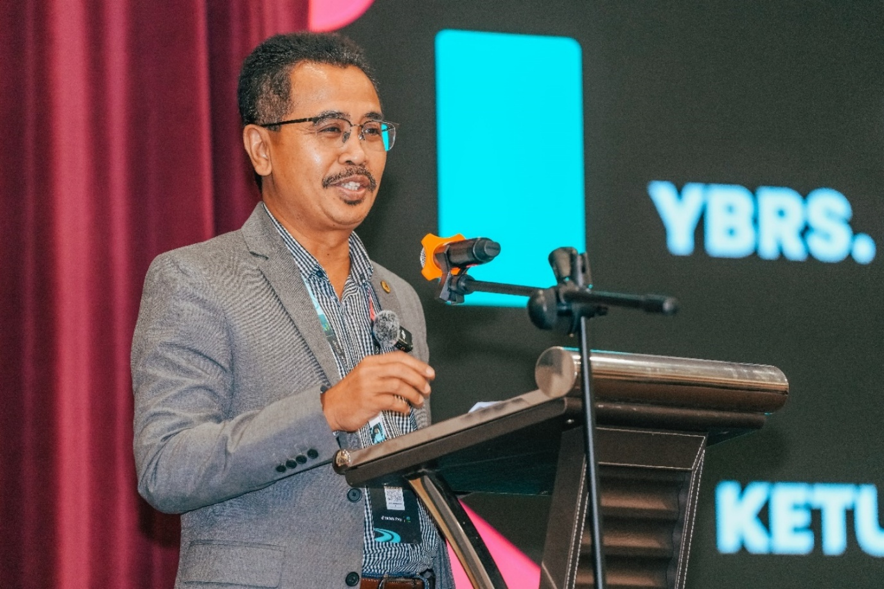
Figure 1. YBrs. En. Abdul Rashid bin Bahri, Director-General of the Federal Agricultural Marketing Authority (FAMA), delivering his keynote address at the Agromarketing Masterclass TikTok Shop Edition Grand Final Live Streaming Competition 2024 held at the Grand Banquet Hall, UTMKL Residence, Kuala Lumpur. In his speech, he highlighted that the collaboration between FAMA and TikTok Shop marks a pioneering initiative that extends beyond conventional training programmes, representing a strategic effort to address current challenges and embrace the evolving landscape of digital marketing.
Figure 1 captures authoritative ecosystem orchestration at the programme's apex. Keynote participation by FAMA's Director-General communicates institutional commitment that can reduce SME uncertainty about platform legitimacy—a factor emphasised in international platform-entry research (Giones et al., 2021). Such signalling is analytically relevant because ecosystem governance shapes partner participation and resource allocation before any individual seller achieves marketplace traction.
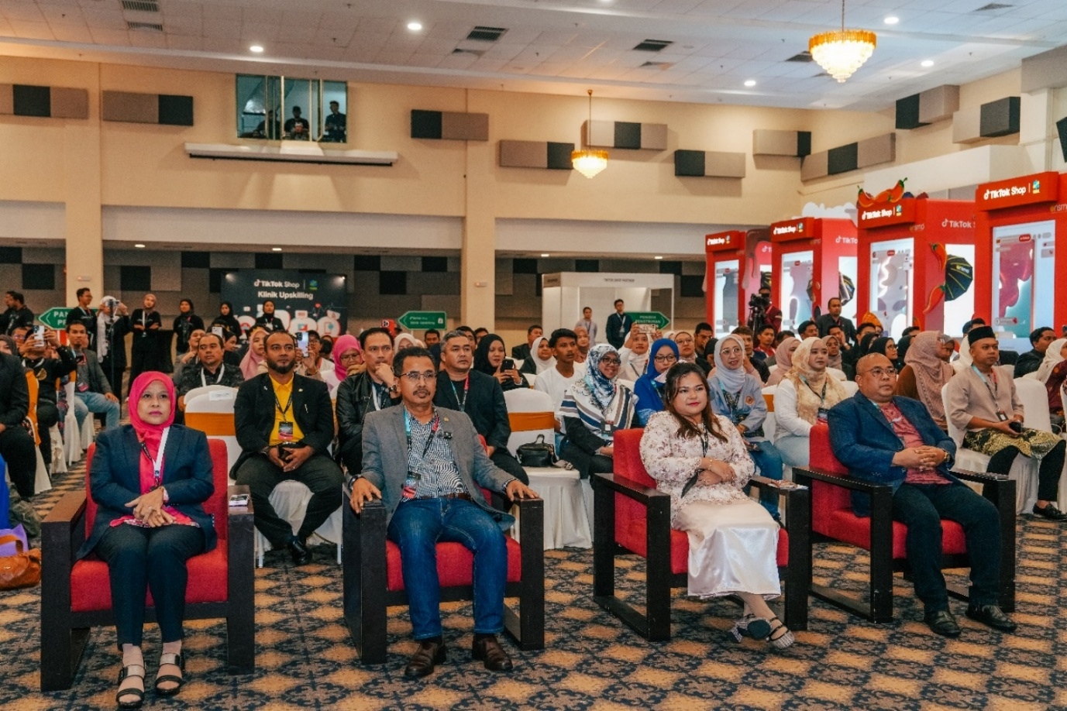
Figure 2. Distinguished guests attending the Closing Ceremony of the Agromarketing Masterclass TikTok Shop Edition Grand Final Live Streaming Competition 2024. The ceremony was officiated by Mr. Abdul Rashid bin Bahri, Director-General of the Federal Agricultural Marketing Authority (FAMA). The event was further graced by the presence of Ms. Rosilawati binti Abu Hassan, Deputy Director-General (Management Services) of FAMA; Mr. Faisal Iswardi bin Ismail, Deputy Director-General (Development) of FAMA; and Ms. Nur Azre binti Abdul Aziz, Director of Strategic Relations, TikTok Shop Malaysia.
Figure 2 illustrates ceremonial closure and stakeholder co-presence, practices that strengthen network density within the programme ecosystem. International business research on digital internationalisation stresses that visible institutional sponsorship can catalyse trust among entrepreneurs, platform representatives and buyers (Zaefarian et al., 2022). The gathering therefore represents a social infrastructure complement to technical platform access.
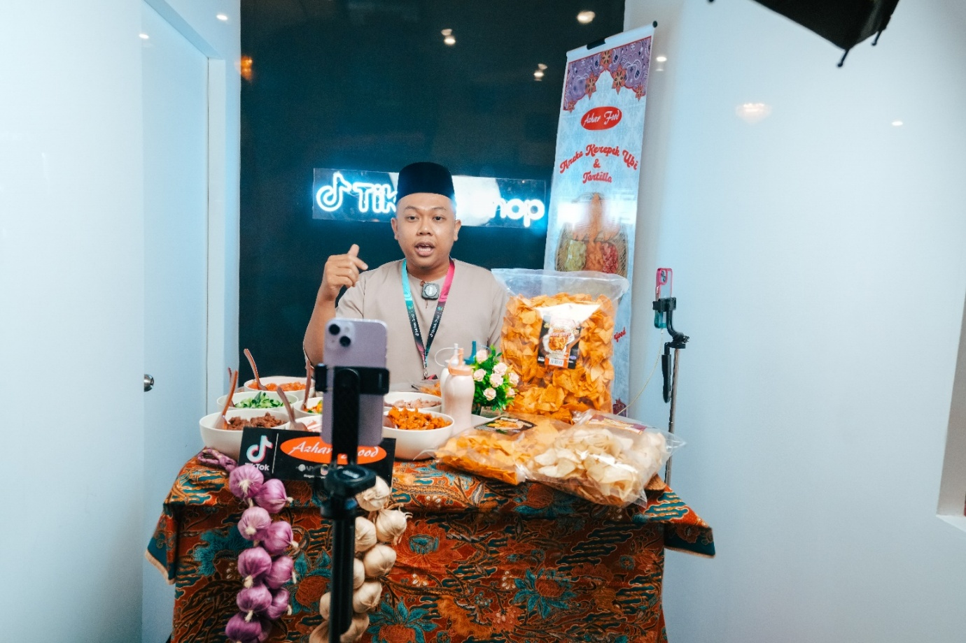
Figure 3. Azhar Food, one of the Top 5 companies selected for the Live Streaming Competition 2024, conducting an online sales session through the TikTok Shop platform during the Grand Final event. The company achieved a total sales value of RM 1,773,890.82 throughout the competition period from June to November 2024, securing third place overall in the live streaming competition.
Figure 3 exemplifies livestream orchestration capability under competitive conditions. The scene shows real-time conversion work—product narration, audience interaction and transactional prompting—rather than passive content posting. This visual evidence aligns with the channel-level results in Table 3, where livestream sales contributed nearly one-third of total GMV, and with Wibawa et al.'s (2022) emphasis on active platform utilisation as a performance driver.
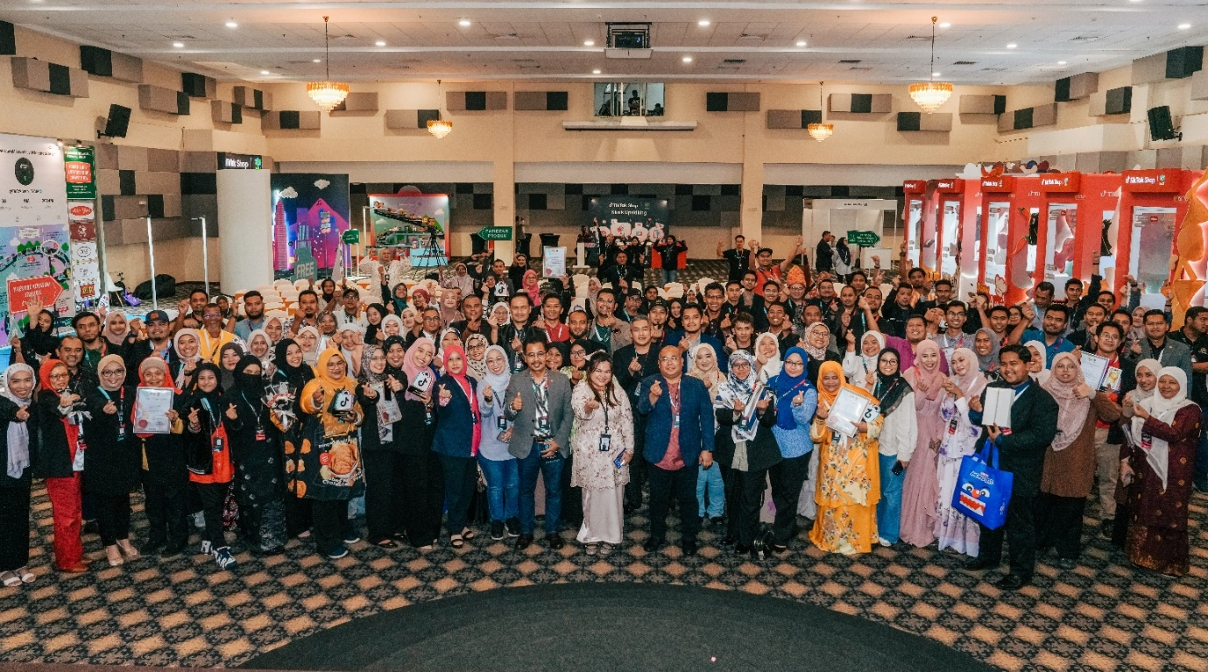
Figure 4. Participants of the Agromarketing Masterclass TikTok Shop Edition programme posing with distinguished guests and winners following the completion of the official closing ceremony.
Figure 4 highlights peer learning and community mobilisation, intangible ecosystem resources that RBV scholarship often treats as socially complex and difficult to imitate (Barney, 1991). The collective visibility of winners and participants may reinforce entrepreneurial identity and accelerate diffusion of best practices in short-video and livestream selling across the participant network.
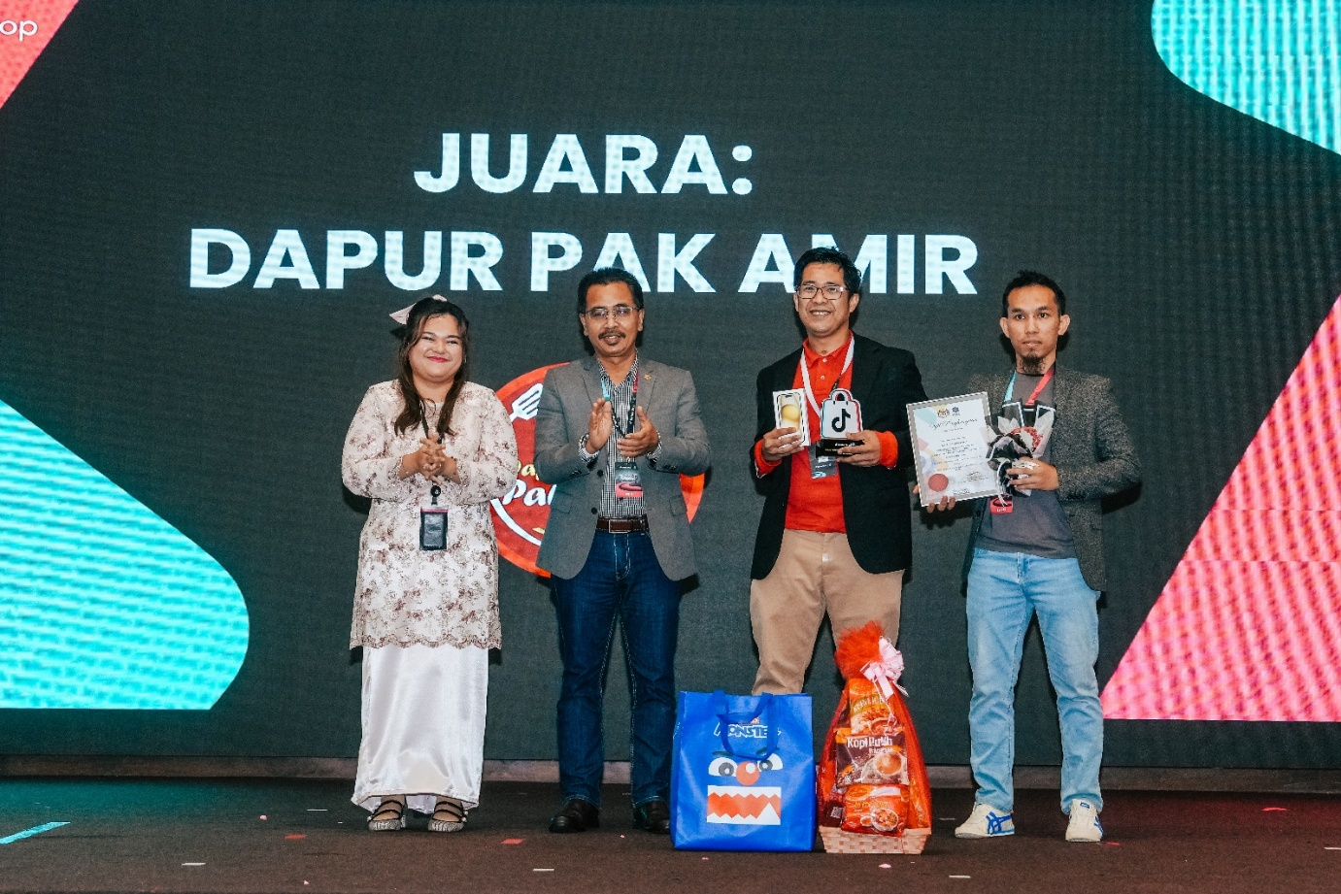
Figure 5. Despite being a person with disabilities (PWD), Dapur Pak Amir demonstrated outstanding determination and perseverance, earning the Champion title in the Live Streaming Competition. The award was presented by Mr. Abdul Rashid bin Bahri, Director-General of the Federal Agricultural Marketing Authority (FAMA), and witnessed by Ms. Nur Azre binti Abdul Aziz, Director of Strategic Relations at TikTok Shop Malaysia.
Figure 5 provides compelling evidence of inclusive ecosystem capability. Dapur Pak Amir's championship status corresponds with its top-ten December GMV ranking in Table 5, suggesting that orchestrated training and competitive exposure can translate into measurable monetisation for under-represented entrepreneurs. This finding extends Islam et al.'s (2023) digital transition discourse by showing that capability-building architectures may reduce participation barriers for PWD-owned SMEs when ecosystem governance explicitly supports inclusive competition.
Contributions
Theoretical contribution. This study advances international business theory by reframing social commerce performance as an outcome of orchestrated platform ecosystem capability rather than isolated technology adoption. It integrates RBV and Dynamic Capabilities Theory to explain why revenue-bearing complements co-move over time while raw content volume does not automatically predict monetisation. In doing so, it responds to Ammeran and Latip (2024) by linking Malaysian SME digital transformation discourse to observable marketplace indicators within a specified platform architecture.
Managerial contribution. SME leaders should treat TikTok Shop not as a single sales channel but as a portfolio of interdependent capabilities requiring coordinated investment in livestream conversion, short-video demand generation and profile-window trust building. Managers should also monitor order and product-movement metrics alongside content production because the correlational results indicate that commercial integration matters more than content volume alone. Firms lagging in ecosystem capability may benefit from structured peer benchmarking akin to the competitive livestream format documented in Figures 3 and 5.
Policy contribution. For agencies such as FAMA, the evidence supports continued ecosystem orchestration that combines training, marketplace activation, competitive events and post-training monitoring. Policy should, however, address spatial concentration and seller-level inequality by channelling additional capability support to peripheral states and lower-performing cohort members. The inclusive achievement of PWD-owned firms suggests that explicit accessibility design within ecosystem governance can yield socially and economically meaningful returns, a consideration aligned with broader digital inclusion agendas (UNCTAD, 2023; World Bank, 2024).
CONCLUSION
This study examined how government-led orchestration of platform ecosystem capability relates to SME monetisation within Malaysia's AMTTSE social commerce intervention. Analysing official programme data for 80 companies and 160 entrepreneurs from June to December 2024, the findings show that cumulative GMV reached RM6,205,957.06 with an estimated ROI of 1:31. Sales were distributed across livestream, profile-window, short-video and shop-tab complements, and monthly aggregates exhibited strengthening associations among channel sales, orders, products sold and total GMV. Visual and seller-level evidence further demonstrated that ecosystem orchestration can support inclusive and competitive entrepreneurship, including high-performing PWD-owned firms.
Several limitations should be acknowledged. First, the correlational analysis relies on seven monthly observations and cannot support firm-level causal inference. Second, seller-level data for December provide only a partial view of capability heterogeneity across the full monitoring period. Third, the study focuses on one platform ecosystem and one policy intervention, limiting immediate generalisation to other international marketplaces. Future research should pursue longitudinal seller-level panel data, compare orchestration models across platforms such as Shopee Live and Instagram Shop, and employ mixed-method designs that link capability-building processes to monetisation trajectories. Notwithstanding these limitations, the study clarifies that international business competitiveness for Malaysian agri-SMEs increasingly depends on orchestrating complementary platform capabilities within governed social commerce ecosystems.
REFERENCES
Adner, R. (2017). Ecosystem as structure: Constructing the construct. Journal of Management, 43(1), 39–58. https://doi.org/10.1177/0149206316672681
Al-Ababneh, M. M., Al-Sharayrah, O., & Al-Sharayrah, M. (2024). Digital transformation and SME performance: A systematic literature review. Journal of Innovation & Knowledge, 9(4), 100567. https://doi.org/10.1016/j.jik.2024.100567
Ammeran, M. Y., & Latip, M. S. A. (2024). Influencing factors of digital transformation in developing economies: A case study of Malaysia's SME sector. International Journal of Business and Society, 25(2), 696–712. https://doi.org/10.33736/ijbs.7623.2024
Barney, J. (1991). Firm resources and sustained competitive advantage. Journal of Management, 17(1), 99–120. https://doi.org/10.1177/014920639101700108
Benitez, J., Henseler, J., Castillo, A., & Schuberth, F. (2023). How to perform and report an impactful PLS-SEM analysis. Industrial Management & Data Systems, 123(5), 1367–1396. https://doi.org/10.1108/IMDS-10-2022-0610
Bouwman, H., Nikou, S., Molina-Castillo, F. J., & de Reuver, M. (2021). The impact of digitalization on business models. Digital Policy, Regulation and Governance, 23(1), 41–60. https://doi.org/10.1108/DPRG-07-2018-0044
Cenamor, J., Parida, V., & Wincent, J. (2021). How entrepreneurial SMEs compete through digital platforms: The roles of innovation, international growth, and strategic adaptability. Technological Forecasting and Social Change, 175, 121340. https://doi.org/10.1016/j.techfore.2021.121340
Chan, F. F., Thong, S. Y., & Wong, K. Y. (2022). Social commerce adoption among SMEs: A dynamic capability perspective. Internet Research, 32(4), 1245–1270. https://doi.org/10.1108/INTR-03-2021-0178
Creswell, J. W., & Creswell, J. D. (2018). Research design: Qualitative, quantitative, and mixed methods approaches (5th ed.). SAGE Publications.
Eisenmann, T., Parker, G., & Van Alstyne, M. W. (2021). Platform envelopment. Strategy Science, 6(1), 1–15. https://doi.org/10.1287/stsc.2020.0123
Ermaya, S. K., Ermaya, H. N. L., Saefudin, A., & Gunawan, A. W. (2025). Business intelligence, strategy innovation, and digital value creation for business performance on digital creative industries. International Journal of Business and Society, 26(1), 80–100. https://doi.org/10.33736/ijbs.9548.2025
FAMA. (2024). Projek Perintis Report (December 2024): Agromarketing Masterclass TikTok Shop Edition performance dataset. Federal Agricultural Marketing Authority.
Gawer, A. (2021). Digital platforms' boundaries and governance: A market-shaping perspective. Journal of Management Studies, 58(7), 1753–1774. https://doi.org/10.1111/joms.12706
Giones, F., Brem, A., & Berger, A. (2021). Strategic choices in building the platform: Critical challenges in market entry and expansion. R&D Management, 51(4), 405–419. https://doi.org/10.1111/radm.12446
González-Blanco, J., Coca-Pérez, J. L., & Guisado-Gómez, J. (2022). Digital transformation in SMEs: A bibliometric analysis. Journal of Small Business and Enterprise Development, 29(5), 592–616. https://doi.org/10.1108/JSBED-03-2021-0078
Halim, I. A., Gian Singh, J. K., & Osman, R. (2026). Bridging the digital gap: Factors influencing digital economy adoption in small enterprises. Journal of International Business, Economics and Entrepreneurship, 11(1), 32–42. https://doi.org/10.24191/jibe.v11i1.8520
Hein, A., Weking, J., Schreieck, M., Wiesche, M., Böhm, M., & Krcmar, H. (2021). Value co-creation practices in business-to-business platform ecosystems. Electronic Markets, 31(2), 503–521. https://doi.org/10.1007/s12525-019-00377-7
Helfat, C. E., & Raubitschek, R. S. (2021). Dynamic and integrative capabilities for profiting from innovation in digital platform-based ecosystems. Research Policy, 50(8), 104284. https://doi.org/10.1016/j.respol.2018.01.019
Hilmi, N. F., & Ramli, N. F. (2022). Social commerce adoption among Malaysian SMEs: An integrated model. Journal of Science and Technology Policy Management, 13(3), 456–478. https://doi.org/10.1108/JSTPM-05-2021-0089
Islam, A. A. A., Trinugroho, I., & Suryanto. (2023). SMEs' flight to digital and green economy: Evidence from Indonesia. International Journal of Business and Society, 24(1), 362–379. https://doi.org/10.33736/ijbs.5622.2023
Jacobides, M. G., Cennamo, C., & Gawer, A. (2018). Towards a theory of ecosystems. Strategic Management Journal, 39(8), 2255–2276. https://doi.org/10.1002/smj.2904
Kraus, S., Palmer, C., Kailer, N., Kallinger, F. L., & Spitzer, J. (2022). Digital entrepreneurship: A research agenda on new business models for the twenty-first century. International Journal of Entrepreneurial Behavior & Research, 28(5), 1172–1193. https://doi.org/10.1108/IJEBR-06-2020-0459
Li, F. (2021). The digital transformation of business models in the creative industries: A holistic framework and emerging trends. Technovation, 102, 102214. https://doi.org/10.1016/j.technovation.2020.102012
Li, Y., Dai, J., & Cui, L. (2022). The influence of digital technologies on economic growth among countries. Information Technology for Development, 28(4), 733–750. https://doi.org/10.1080/02681102.2021.1943377
Loebbecke, C., & Picot, A. (2022). Reflections on societal and business model transformation arising from digitization and big data analytics. Journal of Strategic Information Systems, 31(1), 101–110. https://doi.org/10.1016/j.jsis.2015.08.002
Matarazzo, M., Penco, L., Profumo, G., & Quaglia, R. (2021). Digital transformation and customer value creation in made in Italy SMEs. International Journal of Production Economics, 234, 108046. https://doi.org/10.1016/j.ijpe.2021.108046
McIntyre, D. P., & Srinivasan, A. (2021). Networks, platforms, and strategy: Emerging views and next steps. Strategic Management Journal, 42(3), 441–460. https://doi.org/10.1002/smj.2596
Muzellec, L., Ronteau, S., & Lambkin, M. (2021). Two-sided internet platforms: A business model lifecycle perspective. Industrial Marketing Management, 92, 290–303. https://doi.org/10.1016/j.indmarman.2020.05.004
Nambisan, S. (2021). Digital entrepreneurship: Toward a digital technology perspective of entrepreneurship. Entrepreneurship Theory and Practice, 45(4), 1029–1055. https://doi.org/10.1111/etap.12254
Ojala, A., Evers, N., & Rialp, A. (2021). Extending the international new venture phenomenon to digital platform providers. International Business Review, 30(2), 101792. https://doi.org/10.1016/j.ibusrev.2020.101792
Parker, G. G., Van Alstyne, M. W., & Choudary, S. P. (2021). Platform revolution: How networked markets are transforming the economy (updated ed.). W. W. Norton & Company.
Putit, L., Hamzah, M. I., Abdullah, M. F., Syed Annuar, S. N., & Yulianto, A. (2025). Drivers of social media marketing continuance among MSMEs in emerging economies. Journal of International Business, Economics and Entrepreneurship, 10(2), 86–97. https://doi.org/10.24191/jibe.v10i2.8743
Raub, N. A. A., Aluwi, A. H., Zainal Abidin, N. I., & Maulida, E. (2025). Strategic marketing and digital transformation for SME empowerment: Insights from a Malaysia–Indonesia service-learning collaboration. Journal of International Business, Economics and Entrepreneurship, 10(2). https://doi.org/10.24191/jibe.v10i2.8197
Rialp, A., Rialp, J., & Knight, G. A. (2021). International entrepreneurship in the digital economy: A research agenda. Journal of International Management, 27(4), 100868. https://doi.org/10.1016/j.intman.2021.100868
Rindfleisch, A., O'Hern, M. S., & Sachdev, V. (2021). The digital revolution, 3D printing, and innovation. Journal of Business Research, 124, 1–9. https://doi.org/10.1016/j.jbusres.2016.12.006
Ritter, T., & Pedersen, C. L. (2021). Digitization capability and the digitalization of business models in business-to-business firms. Industrial Marketing Management, 92, 178–188. https://doi.org/10.1016/j.indmarman.2019.07.002
Sahut, G., Hikkerova, L., & Dandoy, A. (2021). The digital transformation of business models: A systematic literature review. Journal of Business Research, 122, 389–400. https://doi.org/10.1016/j.jbusres.2020.08.048
Sekaran, U., & Bougie, R. (2021). Research methods for business: A skill-building approach (9th ed.). Wiley.
Srinivasan, R., & Venkatraman, N. (2021). Entrepreneurial orientation in the digital age: The contingent role of digital capabilities. Strategic Entrepreneurship Journal, 15(2), 533–549. https://doi.org/10.1002/sej.1300
Teece, D. J. (2018). Business models and dynamic capabilities. Long Range Planning, 51(1), 40–49. https://doi.org/10.1016/j.lrp.2017.06.007
Teece, D. J., Pisano, G., & Shuen, A. (1997). Dynamic capabilities and strategic management. Strategic Management Journal, 18(7), 509–533. https://doi.org/10.1002/(SICI)1097-0266(199708)18:7<509::AID-SMJ882>3.0.CO;2-Z
Tiwana, A. (2021). Platform ecosystems: Aligning architecture, governance, and strategy (2nd ed.). Morgan Kaufmann.
Troise, C., Corvello, V., Ghobadian, A., & O'Regan, N. (2022). How SMEs pursue digital transformation: A systematic literature review. International Journal of Entrepreneurial Behavior & Research, 28(8), 1–25. https://doi.org/10.1108/IJEBR-03-2021-0240
UNCTAD. (2023). Digital economy report 2023: Shaping an environmentally sustainable and inclusive digital future. United Nations Conference on Trade and Development.
Van Alstyne, M. W., Parker, G. G., & Choudary, S. P. (2021). Pipelines, platforms, and the new rules of strategy. Harvard Business Review Digital Articles.
Verhoef, P. C., Broekhuizen, T., Bart, Y., Bhattacharya, A., Dong, J. Q., Fabian, N., & Haenlein, M. (2021). Digital transformation: A multidisciplinary reflection and research agenda. Journal of Business Research, 122, 889–901. https://doi.org/10.1016/j.jbusres.2019.09.022
Wibawa, B. M., Baihaqi, I., Nareswari, N., Mardhotillah, R. R., & Pramesti, F. (2022). Utilization of social media and its impact on marketing performance: A case study of SMEs in Indonesia. International Journal of Business and Society, 23(1), 19–34. https://doi.org/10.33736/ijbs.4596.2022
World Bank. (2024). Malaysia digital economy blueprint: Progress and SME inclusion. World Bank Group.
Yin, R. K. (2018). Case study research and applications: Design and methods (6th ed.). SAGE Publications.
Zaefarian, G., Henneberg, S. C., & Naudé, P. (2022). Capability development in international new ventures: A systematic literature review. International Business Review, 31(1), 101894. https://doi.org/10.1016/j.ibusrev.2021.101894
Zhang, M., Luo, Y., & Li, Y. (2021). The role of digital platforms in international entrepreneurship. Journal of International Management, 27(4), 100869. https://doi.org/10.1016/j.intman.2021.100869
Zhu, F., & Iansiti, M. (2021). Why some platforms thrive and others don't. Harvard Business Review, 99(1), 118–125.
Zhu, F., & Liu, Q. (2021). Competing with complementors: An empirical look at Amazon.com. Strategic Management Journal, 42(3), 2618–2642. https://doi.org/10.1002/smj.2925
Zuboff, S. (2021). The age of surveillance capitalism: The fight for a human future at the new frontier of power (reprint ed.). PublicAffairs.
de Reuver, M., Sørensen, C., & Basole, R. C. (2021). The digital platform: A research agenda. Journal of Information Technology, 36(2), 124–135. https://doi.org/10.1057/s41265-016-0033-3
Öberg, C., & Alexander, A. T. (2022). Digital internationalization: A systematic literature review and future research agenda. International Business Review, 31(6), 102052. https://doi.org/10.1016/j.ibusrev.2022.102052
Abou-Foul, M., Adams, F. G., & Borah, A. (2021). The impact of platform and seller characteristics on e-commerce sales: An examination of seller platforms in the UAE. International Journal of Research in Marketing, 38(4), 931–949. https://doi.org/10.1016/j.ijresmar.2021.02.001
Chen, Y., Wang, L., & Xie, Y. (2022). Online social interactions and consumer financial decisions: Evidence from a social commerce platform. Management Science, 68(8), 5645–5666. https://doi.org/10.1287/mnsc.2021.4105
Dwivedi, Y. K., Ismagilova, E., Hughes, D. L., Carlson, J., Filieri, R., Jacob, N., ... Wang, Y. (2021). Setting the future of digital and social media marketing research: Perspectives and research propositions. International Journal of Information Management, 59, 102168. https://doi.org/10.1016/j.ijinfomgt.2020.102168
Foss, M., & Saebi, T. (2021). Business models and business model innovation in digital entrepreneurship. Journal of Business Research, 125, 840–847. https://doi.org/10.1016/j.jbusres.2020.11.088
Huang, L., Zhang, Y., & Zhang, Y. (2023). Live streaming commerce and consumer purchase intention: A social presence perspective. Electronic Commerce Research, 23(2), 801–826. https://doi.org/10.1007/s10660-021-09525-2
Kumar, V., Ramachandran, D., & Kumar, B. P. (2021). Influence of new-age technologies on marketing: A research agenda. Journal of Business Research, 125, 864–877. https://doi.org/10.1016/j.jbusres.2020.10.024
Leong, L. Y., Hew, J. J., Tan, G. W. H., & Ooi, K. B. (2021). Live-streaming commerce on social media platforms: An affordance perspective. Journal of Retailing and Consumer Services, 63, 102744. https://doi.org/10.1016/j.jretconser.2021.102744
Rahim, N. A., Yusuf, M. A., & Che Mat, N. (2024). Social commerce and shoppertainment adoption among Malaysian consumers. Journal of Digital Business and Marketing, 4(2), 45–61.
Susanto, A., Chang, Y., & Ha, Y. J. (2021). Determinants and outcome of SME digital transformation: A dynamic capability perspective. Sustainability, 13(16), 9001. https://doi.org/10.3390/su13169001

